Main Daily Conversation
Block 2 to 3 (What I Did): (UPDATED: 06/10/2026)
- General Notes: - Please Review
  - I worked just on the “Written Report” part of the “Final Report” assignment.
  - He did note that he wasn’t going to pull anyone from their blocks for presentations tomorrow. I asked him already and also mentioned you, specifically Maddie, and if you could come up during Gym. He mainly said that he wasn’t really sure if he wanted that and that I probably know everything already anyway. Still, he also mentioned asking the proper teacher(s) and that it was still a possibility he wasn’t really sure on. I cannot stress this enough, Maddie, but PLEASE ASK EVERYONE YOU NEED TO TODAY (that being Mrs. Galea and Dr. Bixler). I would really prefer you to be here since I definitely do not know everything well and I would definitely struggle to do everything myself. PLEASE PUSH FOR THIS, Maddie. I really don’t want to have to present on my own. I also KNOW I would need help with the demo (like last time) so PLEASE MENTION THAT TOO IF NEEDED. Please try and allow this and tell me how everything goes TODAY.
  - I partially reworked my plan for how things will go in terms of work. None of this should really change even with the POSSIBILITY of me having to present on my own. Still, please push for this, Maddie. I am so cooked.
  - These notes will also not be retired until after tomorrow so YAY I guess because of the extensions, lol.
  - Just as a simple final note to end this section, I am assuming that Liam can now spend time working on a portion of the “Written Report” too so we can try and divide up the work at least a little more evenly. Is this too much to ask or is this okay?
- “Final Report” Assignment Notes:
  - I just worked on the “Written Report.”
    - I specifically spent a lot of time working in the “Detailed Summary” section specifically on just my work detailed during the project.
      - I am not currently finished with this and it still needs to be done.
- Notes for 06/10/26:
  - Generally, at least for my plan and what I want to do right now, I plan on finishing my part of the “Written Report” tonight since I have written seven total pages of the “Written Report” and I want to finish at least my section of the progress I specifically made during the project. I left off with this part at “Sprint 3” so I plan on writing down all progress I made in the project after “Spring 3” tonight! After I finish with that, I plan on spicing up the “Written Report” in my parts of it with some images (possibly with the help of you guys). After that, I was going to spend some time making sure I reviewed the “In-Class” presentation to make sure it looks good for submission (regardless of if every last detail is actually done since Liam is going to be working late (and I trust he can make sure it looks good for submission and that he can submit it)). After that, I will probably just go over anything I want to to prepare for the presentation tomorrow (that being the Trello and making sure it is updated with the help of you guys, the presentation itself, the GitHub repo (same thing applies), etc.). Lastly, I want to record my section of the 6 to 10 minute Final Video tonight preferably so we don't have to do all of the video tomorrow in terms of editing and such. If needed, I can always record tomorrow and just plan tonight for the video if I want to. I will make sure to note this in my “One Last Note(s)” section. This also means we have to also create/ have an at least semi-clear idea of what we want to do with the video done tonight too if we decide to do it tonight. I wanted to list all of this because tomorrow, I plan on doing slightly different things based on the updated due dates. I just wanted to clarify how things were going today before I mentioned why I am doing what I am doing tomorrow and/ or what I am doing tomorrow specifically. For tomorrow, since presentations will take up all of class time tomorrow, after school, I mainly plan on not doing much in terms of what got pushed back to being due Friday morning. Mainly, I will just help out where needed, but I probably should have all of my stuff done by then anyway so if I do end up doing something I won't do much. I will also review the parts of the project due Friday morning when you guys finish them (if possible) just as one final last check. Essentially, that should be it for this Senior Capstone notes document. Just keep me updated and I will do the same too. Thank you guys for everything this year!
- Response to/ for Block 3: N/A
- One Last Note(s) from 06/10/26:
  - During class, just make sure you, Maddie, come to class before presentations start. I preferably want to present first so we can get it over with. I have already mentioned to you all of the details I wanted to regarding actually presenting in your DMs so just review that there. After school, I managed to fully finish my part of the “Written Report,” “In-Class Presentation,” and “Final Video.” Realistically, if you need me too, I am always available tomorrow if you guys need anything else from me since the “Written Report” and “Final Video” are due tomorrow. Realistically, though, there was really nothing else I wanted to do for the final parts of the project. I also don’t know how much I would be around tomorrow too so I made sure to do as much as I could without you guys today. Anyway, I am sure I have made enough comments where needed on everything and sent a bunch of discord messages, but if you need anything still just message me. This should be the last time we use this document since everything should be done by tomorrow (at least just the work in class). Just keep me updated on everything and I will do the same too! The only thing I will really be doing is just checking things before submission and marking things as done. Thank you guys for your hard work this semester! I really appreciate it.

Block 3 to 2:
- Got approval from Galea to come up block 2 we will see about Bixler
- Also the not being able to jump issue is like 10 times worse now in the CL branches
- Can’t automatically merge main into the CL branches. At the end of the day we will have everyone so I will merge all the CL branches together and then merge main into that to work on tonight.
- I also got everyone who I asked during Block 2 so all I need it to ask Block 4 gym people/lunch
- I will mostly be working on the report in class today due to everything in the CL branches
- Planning CL level ignore
- Ian > Doug > Finn > Kat > Sam > AC > Noah

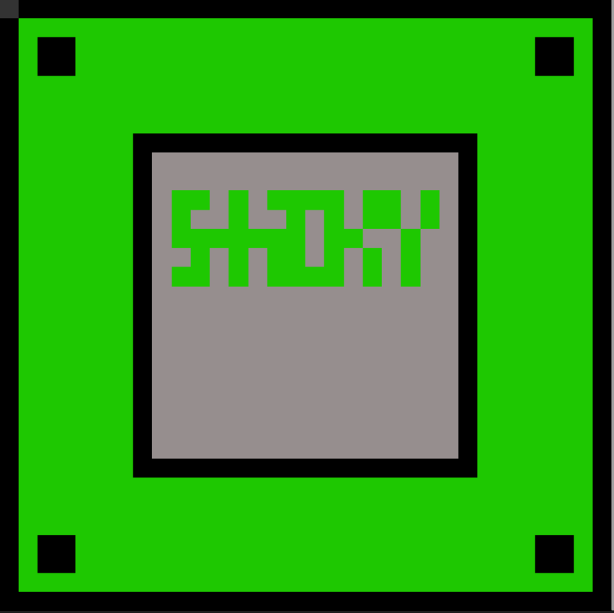
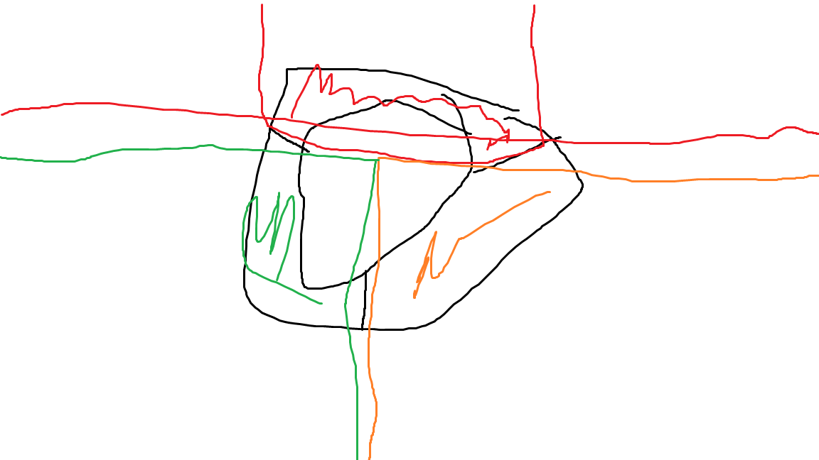
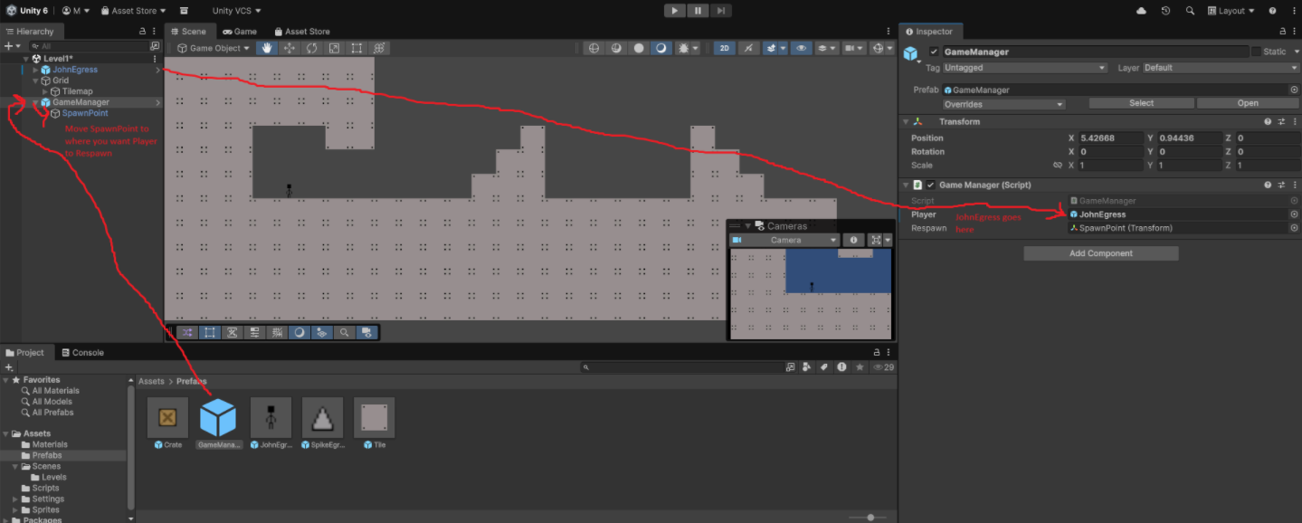
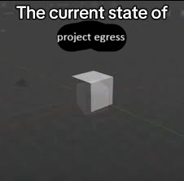




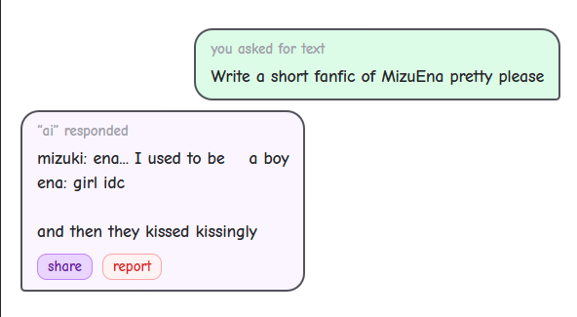
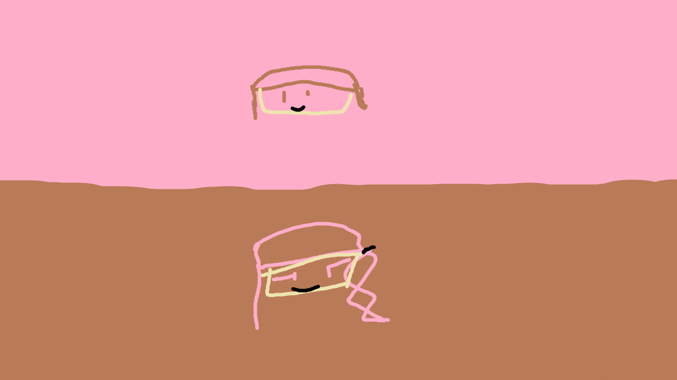
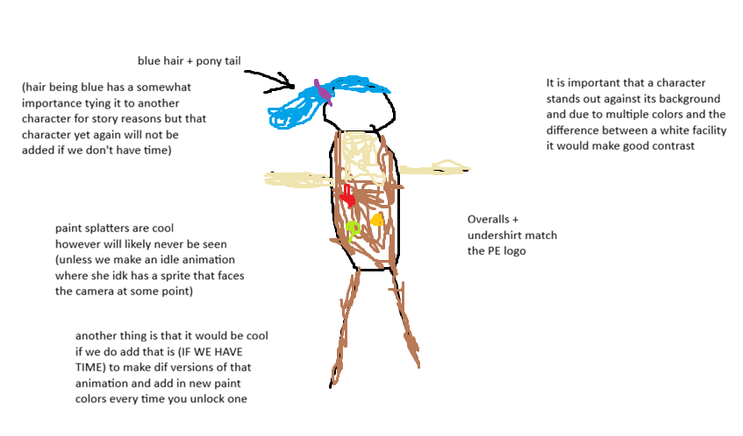

Story
Figured I would write a quick synopsis - Maddie
(for now I don’t have a name for the two characters so they will just be called the engineer and robot)

Essentially the engineer wakes up in the facility with no idea why she is there. It is a cell-like area like Portal. They proceed to walk into the facility where a whole bunch of wacky stuff will happen. About a quarter of the way through from behind the engineer hears a voice which is the robot saying “Oh no where did she go”. The engineer tries to hide but fails. The robot tries to explain why the engineer is there but the engineer doesn’t listen. At the end the robot explains why it was trying to stop the engineer from leaving (some apocalypse shit happened and the robot saved her) and then there are two different endings Egress? and Egress? (stay or leave) Stay is good ending as the robot was telling the truth and happi day or what not. Leave is the bad ending as you are now thrown into an apocalyptic world alone sadge day.

03/12/26 Archive
Block 2 to 3 (What I Did): (UPDATED: 03/12/2026 & ARCHIVED)
- What is the current state of branches and stuff? Is everything I have been doing fine and merged into main and stuff right now?
  - He made a note earlier about making sure everything is committed properly and stuff and I want to make sure what I have been doing is fine.
- I started messing around with the “Hi” scene after making a new “New-Level-Test” branch off of “Sandbox” in Github.
- Notes for 1st bit of level creation.
  - I need to make proper flooring in Piskel.
  - Crates should have physics when they are on the flooring.
    - There is a 0.37 difference between crates on the X-Axis.
    - There is a 0.35 difference between crates on the Y-Axis.
  - I need to figure out how to start coding when I need to. How? When? Is crate physics a part of this? Can you create a space for me to work in? I am currently building off of the “Hi” scene.
  - Also, is there just going to be a bunch of crate prefabs in the level? Is there a way to condense everything with flooring? I am not asking to condense all of the boxes, but I am more so referring to how we will create the flooring since the smaller it is, the less bad it looks in resolution/image quality, but also the smaller it is, the more individual floor tiles we will need.
  - I know I won’t be doing this with the boxes (since they will have physics later once we get flooring ready, but in terms of flooring, I noticed how the movement on top of the box floor currently is a bit off and John Egress gets stuck easily. Do you know how to fix that? They are all at the same y-coordinate with overlapping boundaries on the x-coordinates. Just test it.
  - Some general collision errors:
    - Weird random stuck issue with the boxes and John Egress like I mentioned previously.
    - John Egress hovers above the boxes slightly. This is due to the collisions for the box not matching with the art. This is a lower priority since it is just an aesthetic thing.
    - John Egress can not jump while on top of John Egress. I don’t know if you want this lol.
    - That is essentially it, but I suggest you test yourself.
- No need to save in VS Code because I only worked directly in Unity. I just commit in VS Code.
- Note for 03/12/2026: Make a branch from sandbox for the level

Block 3 to 2:
- Daily reminder to git fetch & git pull before making changes
- Ansewers to questions
  - 1. Currently, player-movement is done and not needed for now (do not delete), sandbox will be updated for the sandbox level, and your first level branch will likely be the first branch we merge into main (either this or sandbox will be merged first). No need for merging into main right now.
  - 2. To do coding things, go to the scripts folder in Unity and right click in empty space and go to Create -> Monobehavior Script. Name it and then it can be accessed on vscode through either the explorer or by double clicking on it. To use the script, click on the object you want to add the script to and then drag the script into the Inspector (right side area). Anything related to physics is handled by the Rigidbody2D (unless you want to apply an outside force that is not initiated by the player interacting with it). If the crate doesn’t have Rigidbody2D, it doesn’t get physics and will just stand there. lmk if you want that
  - 3. Prefabs will be used a lot in levels. To condense things, you can always just right click on the top left panel and press Create Empty and then move all the flooring and parts into there, where you can then just collapse it. For the rest in that bullet, see notes below
  - 4. Testing a fix on it, swapped out the box collider with a capsule collider, seems fixed
- Notes
  - Based on bullet 2, I have created a Level1 scene inside the Levels folder of the Scenes folder
    - Reverted your changes to the Sandbox scene (you said you were working in the “Hi” scene but you were saving to the Sandbox scene.). The changes that you have made have been moved over to the new level.
  - Bullet 3: see the Sandbox scene, there are tiles in there for flooring (unless those are for the background)
    - had more to say but ran out of class time
  - Based on bullet 4, will make that change reflect across all branches later
- Maddie is working on getting deaths and respawns working in Death-Respawn branch

03/13/26 Archive
Block 2 to 3 (What I Did): (UPDATED: 03/13/2026 & ARCHIVED)
- I made an archive of yesterday’s conversation and renamed the side tabs accordingly on this document.
- I finished a cool new floor [not the background tiles yet] tile and sent it to you guys. It is animated and I spent a little bit of time cleaning it up.
- I worked on level creation more! Some notes below.
  - I don’t know when I will start using other tiles, but I'm just wondering. How do I add other tile sprites into the side bar to get them into the playspace/hierarchy? It’s probably easy but I don’t know.
  - Also, why was one of the tiles rusted when playing it didn’t appear like that in the hierarchy? Is it random? Can we make a priority for tile randomization to make the standard one more likely than the others?
  - Another question, regarding collision/movement. Is wall sticking/climbing going to be a feature? When you hug the side of a wall, it allows you to stick to it and repeatedly jump to climb up it.
  - There is a bug causing a random bump/bounce when on the floor. Is it the same issue as before with collision?
  - I made sure to align the tiles with the actual grid in the hierarchy. I think they are sized properly for the grid, but you can check it.
- Didn’t do too much today, but that’s essentially it. I laid out more tiles and also created a folder thing to group/collect all of the tiles in. I saved and committed to Git (:
  - I don’t know if I did, but please tell me I worked in the first level space like I should have. If I didn’t, can you fix it, please.
- Note for 03/16/26: Everything should be ready to continue (in the level 1 scene) and is not in the Sandbox scene anymore.

Block 3 to 2:
- Daily reminder to git fetch & git pull before making changes
- Answers:
  - 1. You can just drag a sprite into the hierarchy and it’ll be there, but this will probably be discouraged in the future if we want some tiles to have specific functions. For now, you can do that. The things I said in 2 will not apply to those tiles that were dragged in.
  - 2. I coded the tiles so that it selects a random tile from the sprites, yes. By default, all tiles are the gray tile, but changes randomly upon start. Yes, I can make tile randomization favor the default gray tile more.
  - 3. Not sure about wall sticking, but wall climbing should not be a feature tbh, unless we want a tile that is made specifically for wall climbing (which def can be done)
  - 4. How does this happen? Do you bounce randomly when just moving side to side or when jumping around? I can’t seem to replicate it.
- E Ten + if you ever don’t know what to do you can work on the main character to replace the placeholder
- Hihi story person here so I think it would make sense if the player started out in an area with mostly shiny tiles then transition more into normal tiles and at some point in a level maybe they fall down into a deeper level of the facility and that is where the rusty tiles are used (instead of having all the tile types together
- Notes:
  - You did not use the Level1 scene located in Assets > Scenes > Levels, stop editing sandbox
    - double click on the scene to open it
    - will fix soon (tm)
- Lean in bag to do:
  - (done) fix sandbox and level1 scenes
  - (needs merges) gray tile favored in randomization
    - it should be chosen ~90% of the time (sandbox branch only, will merge into other branches later)
  - (working on it) bug fix (yippee)
    - make player movement changes
- Welcome one welcome all to do:
  - Fix my branch bc oh it is so broken

03/16/26 Archive
Block 2 to 3 (What I Did): (LAST UPDATED: 03/13/26 & ARCHIVED)
- The progress report might be due later than the current date.
- Current Level Plan (feel free to adjust it) - it condenses all the ideas I think we need for a fleshed out game in the minimum amount of levels possible - note that the focus is just the main thing and previously introduced mechanics will likely be expected to be used later throughout progression:
  - Level 0 (Tutorial)
    - Focused on both the platforming and the paint.
    - We could make it literally about spreading paint or we can just use the pre-painted blocks (although I suggest just pre-painted blocks).
  - Level 1 [IN PROGRESS]
    - Focused on skilled platforming maybe with some pre-painted blocks mixed in if you guys want to (although I mainly suggest skilled platforming, not paint in any way yet).
  - Level 2
    - Focused on [TBD PAINT COLOR - 1st paint color] and [TBD PAINT TOOL - 1st tool].
  - Level 3
    - Focused on [TBD PAINT COLOR - 2nd paint color] and no new tools.
  - Level 4
    - Focused on [TBD PAINT COLOR - 3rd paint color] and [TBD PAINT TOOL - 2nd tool].
  - Level 5
    - Focused on [TBD PAINT COLOR - 4th paint color] and no new tools
  - Level 6
    - Focused on all paint colors available (as there will be no more new ones) and [TBD PAINT TOOL - 3rd tool]
  - Level 7
    - Focused on all available paint colors and tools (as there are no more new ones of either)
- Liam, did you remove wall climbing because it isn’t there now? Wall sticking is still there though.
- The grid in VS Code is now off-center for some reason and blocks with coordinates previously simple (such as x = 0.5, y = 0.5, etc.) are now still in the grid, but the coordinates are much harder to measure (such as x = -1.04302, y = 0.2001, etc.) when placing tiles since I have to do math to figure out how to get it to fit perfectly like the current ones do (unless there is a way to place a block easily in the grid tile or side-by-side to a current tile). No idea why the blocks didn’t move in the grid, but the coordinates themselves changed.
- Things took forever to load today so I didn’t get much done today.
  - I managed to check in and find a few issues/bugs still in the game itself.
    - Wall sticking is still an issue.
    - Off-Centered/changed tile coordinates.
    - Camera prop missing
  - I worked on the pre-painted tile sprites. These are not finished and probably won’t be until we can figure out what each paint should do. I need to create a general symbol for each pre-painted color tile to keep the facility aesthetic on the tile while also showing visually what the tile might do. Any ideas? Maddie, get some colors and abilities set up like I did the levels so I can work on the sprites. At the earliest, these tiles will be used in the tutorial.
- I committed, but there weren’t any actual changes since I didn’t get to do anything really (as things took forever to load/update/fix since I encountered new issues when loading and the issues I listed above in our game itself - which I did end up solving). If you guys have any fixes to my issues, feel free to do so.
- NOTE TO SELF FOR 03/17/26: Maddie will list colors for sprite making. To fix the box issue, remove all items from the box folder, set folder to (0, 0, 0), and then put everything back in.

Block 3 to 2:
- Answers:
  - 1. Yes, I removed wall climbing. (will be used for green paint (this side note was not lean in bag)).
  - 2. I think those coordinates are based off of the point where all the tiles are sorted into, and not the main area. Will fix see below
  - 3. The camera prop might be missing due to my changes to the JohnEgress prefab. Just try recreating it.
- Did you push? I don’t see any of your changes. I suggest you fix the off-center grid problem yourself by moving all the tiles into the main hierarchy and moving your sorting object to (0,0), then move all the tiles back in.
  - I won’t merge the tiles in until this gets done
- Damaged wall tile has been added under sandbox branch, will be merged with other branches with tiles after ethan pushes ^
- Wall sticking is fixed in player-movement branch, but still needs work as john egress is now soap egress merged

03/17/26 Archive
Block 2 to 3 (What I Did): (LAST UPDATED: 03/13/26 & ARCHIVED)

- Are the normal grey tiles higher priority in the level one scene? I don’t want to bother you, so how would I edit the priority of certain tiles?
- Maddie, please list out the colors and abilities for the game or any ideas you have. I want to start making the pre-painted tile sprites for our tutorial level.
- I am currently manually adding tiles for flooring and walls, but I need some sort of tilemap system to get this going so I can fill in the gaps under the character. Do you know how I could do that, Liam? I just need an easy way to add a large amount of tiles quickly instead of manually duplicating them and setting coordinates.
- What happened to the crate prefab? Also, how do I access the spikes and the platform/moving platform? I want to use moveable boxes, spikes, and other stuff.
- John Egress can jump between a maximum of 5 spaces or tiles or a 5 block gap.
- Edits in Unity Engine:
  - Level1 scene has a camera. You can take a look at it if you want. The space between John Egress’s feet and the floor is a little noticeable, but not too bad. Do with that what you will. You can edit it if you want.
  - I removed JohnEgressDummy. He is no more.
  - I created a space with stairs leading up to a large uncrossable gap.
  - Everything should be saved properly.
- Other Piskel Progress: *EVERYTHING IS EMAILED!*
  - I made a fixed rusted tile to put in the tile script!
  - I made a sloped left and right tile for better movement.
  - I made a singular basic background tile that can be used. What do you guys think? Should it be darker? I tried to go for a shaded tile to kind of act as a backdrop. All it is is just a normal tile but slightly darker. If you guys think it should be darker or have a different idea, just say something. I plan on doing the same “darker” tile concept for the other (currently floor) tiles so just say if you guys want something different. I figured the floor tiles could also make good backdrops since the facility is made out of the same material on all sides presumably. If you guys don’t like it, you don’t have to add it to the project yet.
- NOTES FOR 03/18/26: Red paint will be speed, orange will be bouncy, and green will be sticky. Plan out one more color. Do a tilemap tutorial or find out how to integrate for level creation if possible. General focus for tomorrow should be tilemapping and new Piskel sprites. Major prefabs and mechanics should be merged already so everything should be good.

Block 3 to 2:
- emergency merge revert
  - git revert -m 1 21b89f641921cdaf08a28aa777f834df42352372
- Answers
  - 1. gray tile priority hasn’t been merged yet. i could see if i can make it so that you can adjust priority, but that can be for later (feel free to add to the trello or smth)
  - 2. look at trello, Paint + shooting
  - 3. I don’t know, maybe try looking at a tutorial on how to make a tilemapping system in unity2d
  - 4. I don’t think we’ve ever had a crate prefab. Spikes are currently under the sandbox branch changes to be merged. Moving platforms have not been made yet. I can create a crate prefab, though done
- Working on merging sandbox changes into other branches
- new sprites added
- crate prefab now created

03/18/26 Archive
Block 2 to 3 (What I Did): (LAST UPDATED: 03/18/26 & ARCHIVED)

- How do you guys want to do the paint? Would speed only work on the surface itself or give you a timed movement boost? Do we want to make abilities only on the specific paint surface?
- IT WORKS!!!
  - No friction issues, proper tile priority, and no wall sticking.
  - Nothing is broken.
  - I was thinking tile priority would shift as the levels progress as opposed to only having one tile type per world. Just my opinion.
- Current bugs still:
  - Objects with physics cannot be jumped on for some reason.
  - Death doesn’t work right now. Is it not merged yet?
  - HOLY LAG!!!
- TBD Issues:
  - The art I made for the game doesn’t include borders for the tiles and does include borders for the crates and spikes. Do we want to add stylistic borders on everything? I could update the art if you want it either way, just specify borders or no borders.
- New things:
  - I created and understand how the tilemap works! It should be in the hierarchy and I sized the tiles properly, but when I dragged the prefab in the prefabs folder into the tilemap to click and dragged to place the tiles and pressed play, the randomization was no longer on. This came after I added the tilemap thing (it was fine after the merge). I included the tilemap settings below.
- NOTES FOR 03/19/26: Spike prefab should be set up now. For future reference either look it up or look at details on this document. Art should and will likely be trimmed as it would probably look better. So, just trim the crate and spike sprites. Lag is whatever and randomization is already good/working fine. Actual paint effects will be finalized later so everything for now relating to the abilities will be finalized later.
  - 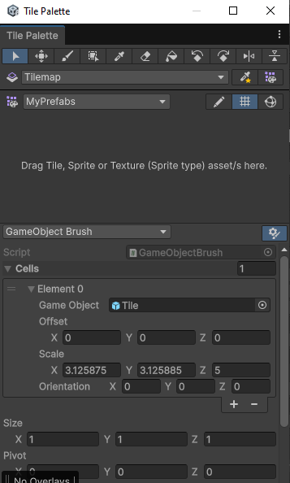

Block 3 to 2:
- Answers:
  - 1. Oki so the way paint will work is that it increases the players movement speed at a certain (undecided) rate and when you get off it will slow down at a different (undecided) faster rate and if you jump or bounce you will either keep your speed or it will deplete at a way slower rate.
  - 2. Death is merged, maybe you didn’t set it up right. Yeah you didn’t set it up right. The lag is not from the game btw, it runs fine. it’s probably just your computer
    - deaths have been fixed for you, but for future ref, see the image below
  - 3. yeah idk, do what you feel like is right for the art
  - 4. the tiles correctly randomize on our ends??

03/19/26 Archive

Block 2 to 3 (What I Did): (LAST UPDATED: 03/18/26)
- Generally speaking, the art right now is placeholder art that may or may not be used (and obviously the character will be updated). What may or may not change are the props, floor, and background itself.
- YAY, the VM crashed while loading the project the first time!
- I started the “Bi-Weekly Progress Report 2” document and shared it accordingly with Liam as the owner.
  - I formatted it properly and did one question roughly.
  - We can mainly work on doing it tomorrow and maybe do other stuff if we get time to.
- Slow start on the VM, per usual. I love random crashes and slow loading.
- I am so dumb, I thought I lost the palette, but I realized it was the brush and that I didn’t lose it. I love this.
  - Barely got anything done again because of this! I added some more tiles and that is all. I plan on figuring out how to add other prefabs to the tilemap so I can add them easily too. I might add another tilemap altogether, honestly.
- In terms of what to do tomorrow, we can kind of just work on whatever is in the “Progress Report.”
  - Make sure to update the TRELLO!!!
  - I will work on whatever, just make sure to finish what I don’t get done.
  - The reason why it’s easier to do whatever is because there are several things that carry over (like the summary that can also be updated a little if you guys think it needs updating) or that there are easier tasks (like managing the trello). I will likely try and focus on the “Issues” and “Individual Progress (my progress part)” sections.
  - PLEASE FOCUS ON THE ASSIGNMENT TOMORROW!!! I ALREADY FORMATED IT TODAY!!! DON’T WORK ON ANYTHING ELSE UNLESS IT IS AN EMERGENCY ISSUE!
- Only actual question: Can I set VS Code to periodically run “Git Fetch” or is that bad? VS Code keeps asking me about this whenever I save and log out.
- Google Docs is transphobic.
- I think everything else is good. I am horrible at actually solving a lot of the issues I run into (that usually have quick fixes, but take me ages), but I think I am learning more about how to solve these issues on my own.
- Use home Google account with the VM to view the TRELLO
- NOTES FOR FUTURE: For now, after the assignment, I will continue to work on level one. It is hard to think of different traps and platforming without the paint mechanic involved (but I think I can manage). I could also try and think of different traps and objects to use and make the first level more interesting. Once I get at least a full shell of the first level (which could take a little bit), I will try and see if I can work on a “level completion” mechanic. I will likely work on updated sprites and art in between everything as well as share my thoughts, plans, and proposals for specific details involving all aspects of our game. On top of level creation, I might mess around with the sandbox too (possibly).

Block 3 to 2:
- Answer:
  - Yeah you can do that if you want
- We did update the trello tho???
- Was originally going to look into paint tiling, but instead focused on fixing a movement bug (it was bad)
  - bug 1: tiny little jumps when moving against a wall
  - bug 2: jumping off walls into the other direction, or just straight up climbing walls
  - low priority

03/20/26 Archive

Block 2 to 3 (What I Did): (LAST UPDATED: 03/19/26 & Archived)
- I marked what needs to be done in yellow and what needs to be checked/possibly updated in purple on the second progress report.
  - My individual progress I have already checked obviously.
  - Make sure to unhighlight everything when you are done checking it.
  - You guys can submit when you are done. Please make sure it is submitted when you can.
- I hooked up my home google account to the virtual machine (as I never really had to use it yet and hadn’t had the time really).
- It didn’t take me too long to do my part of the progress report, so I moved on to other things relatively quickly.
- I can work on the sandbox a little if you want. I can make a more formal space. Just tell me if you do or don’t. Do you want me to or do you just want to use the sandbox as a test space?
- I started to make some updated sprites with my last 30 minutes in the block.
  - I made refurbished versions of nearly every existing tile and sent them. I decided to add borders to everything to make it look better.
  - Is it easy/possible to replace the existing tiles (in game too) (I didn’t change the props as I think they all have borders) with the refurbished ones? They are the exact same size and everything. They are only different in the border itself replacing the normally grey edge.
- I think everything else is good. I sent new (refurbished) versions of all currently existing tiles to you guys. The only one I am a little iffy on is the background tile, but the background isn’t really an important thing right now (that will probably be done much later down the line as it is purely aesthetic). Make sure you get the progress report done. Check my questions here and answer them too. Pre-painted tiles are still in the works right now. (:
- NOTES FOR FUTURE (Last Updated: 03/20/26): For now, after the assignment, I will continue to work on level one. It is hard to think of different traps and platforming without the paint mechanic involved (but I think I can manage). I could also try and think of different traps and objects to use and make the first level more interesting. Once I get at least a full shell of the first level (which could take a little bit), I will try and see if I can work on a “level completion” mechanic. I will continue to share my thoughts, plans, and proposals for specific details involving all aspects of our game. On top of level creation, I might mess around with the sandbox too (possibly). I will try and do the player character sprite when I get the time to in the next two weeks before Spring Break.

Block 3 to 2:
- Answers
  - 1. Feel free to do anything with the sandbox, just remember to make changes to the sandbox scene in the sandbox branch. Keep in mind that the tilemap you added to the first level is not in the sandbox branch, and still uses the old (and bad) system of copy and pasting tiles and lining them up.
  - 2. I’ll figure out something to replace the tiles. It should be possible to replace without breaking anything in theory.
- we worked on the progress report the whole class and there is nowhere to submit it 👍
  - we done with it, feel free to check it
- can we also get an actual player sprite? maddie is crashing out at funky little dancing guy
  - Hey I inferred from the text that the player character was not even gonna be made (we should at least have it done for the midterm)

03/23/26 Archive
Block 2 to 3 (What I Did): (LAST UPDATED: 03/23/26 & ARCHIVED)
- New ideas for the level-making process:
  - Hidden areas (i.e. removing the collision off of tiles to hide secrets)
    - Ryan Geddes gave me this idea.
    - Could add a new sprite: Tile with holes/broken; If you want; It could work so why not.
  - Floating tiles (will look better when background walls surround them).
  - Buzzsaw or moving projectile (will make platforming harder).
    - Lack of traditional enemies also makes this more necessary.
  - Star Coin mechanic (to have hidden/hard to reach collectables to make it more worth to explore the levels).
    - We could also make it a requirement to progress to the end of the game.
  - Random “Markiplier” jumpscare every time you press a key (with a 1/10000) chance to activate - Totally a real idea.
  - Checkpoints (to help delineate between level progression and help with difficulty); Give me some ideas on what the checkpoints should look like (flag, etc.).
  - Falling blocks (that act like Thwomps); I suggested this idea early and gave an animated example; It should already be here.
- Unity Engine work:
  - Significant progress in the platforming level (i.e. level one; should just help players get used to the difficulty/movement with the platforming; NO PAINT YET)
    - I made all the progress with just the spike traps and blocks so far.
    - Tell me if the level is too hard. I beat it on the first try, but I am not sure.
    - I plan to add the checkpoint where it ends after the staircase portion.
  - Everything should be saved and good.
- Sprite work:
  - Tell me if you guys want borders on the background walls too. I suggest no, but I sent you guys two versions already (a bit ago). I need an actual opinion on this. There will be borders on regular tiles (which still need to be implemented), but I personally don’t know about background blocks. I will continue to make two versions for every background tile I make (like I have already), until a decision is made.
  - I sent you guys a new background tile for indicating where secrets are. It should be emailed accordingly.
- Assignment status:
  - He said our progress report had perfect detail and to keep doing what we are doing.
  - We do need to update Github and Trello with more recent tasks/specifics.
    - I will get to looking at Trello and updating my tasks with level-creation tomorrow.
  - He said to work on it at home if needed. I don’t think I need to yet, but if you need something from me and it could take a bit just tell me and I will work on it a little at home.
  - Can you update the lessons learned document like he said to Liam? I don’t know all of the details about the new VM stuff you did with my computer.
- Updates to future progress: I will update Trello tomorrow with my progress and keep doing what I am doing with level-creation and spritework if you guys think that that is good.
- Bugs
  - CRASHED while fetching. Not sure if fetching worked this time because of this…It should have:
  - 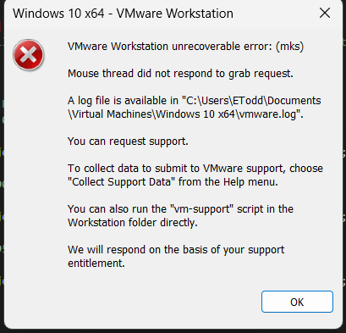

Block 3 to 2:
- Updated the lessons learned document
- **By the way, slope tiles can be reversed by setting one of the options under “Scale” to negative, no need for 2 separate tiles to do this
- Merged player-movement into sandbox
  - ***Planning on adding sandbox into main
- Checkpoint could have a placeholder for now (low detail could even be john egress for now if we want)
  - Essentially I am thinking of the robot character, I will draw a quick sketch, but like a cardboard stand of the character (so like duller colors or what not) and when you pass the checkpoint it gives you a quick thumbs up and maybe some form of checkpoint text (it could also be a sound).
- Liam and I have already been in talk of hidden areas however I don’t think we need blocks to show where they are I think it would be cool to have easter eggs
  - Maybe we could add hidden areas with the weird looking blocks to give more lore but that would require a lot of extra spritework
- I recall us talking about collectables earlier and scrapping the idea but we can have them if you want but just not having them be required
  - Also think it would be cool if they were to be for like finding a faster route rather than a hidden area but perhaps we can have two different kind one for a shortcut and one for a harder platforming section (preferably with its own checkpoint so they don;’t have to travel back to the platforming section (perhaps we can add back more of the puzzle idea that we scrapped too)
- I also think a tiny slap for platforming would be cool (I will provide a sketch) it could allow for harder jumps to be added and stuff.
- ALSO provide me with what specifically you need for creating the main character (do you want a sideview, a character sheet, just a specific part in slightly more detail (at least that ms paint with a mouse/trackpad will allow) just give me what extra stuff you need)

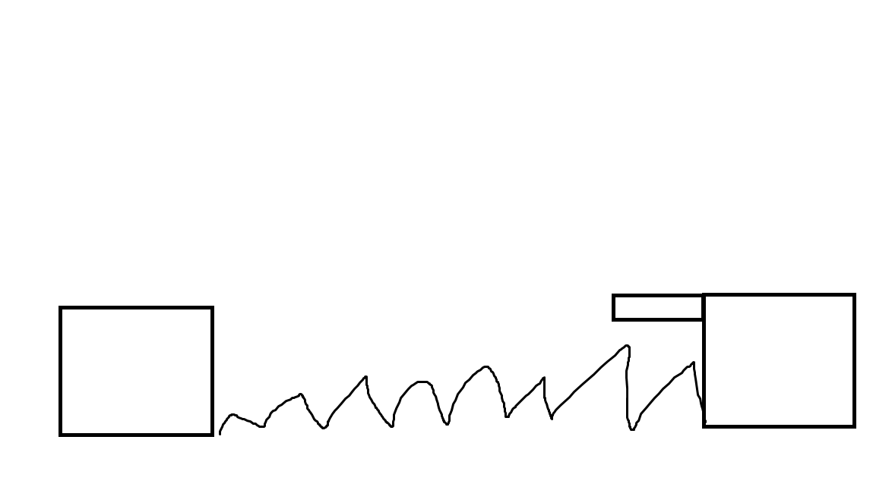
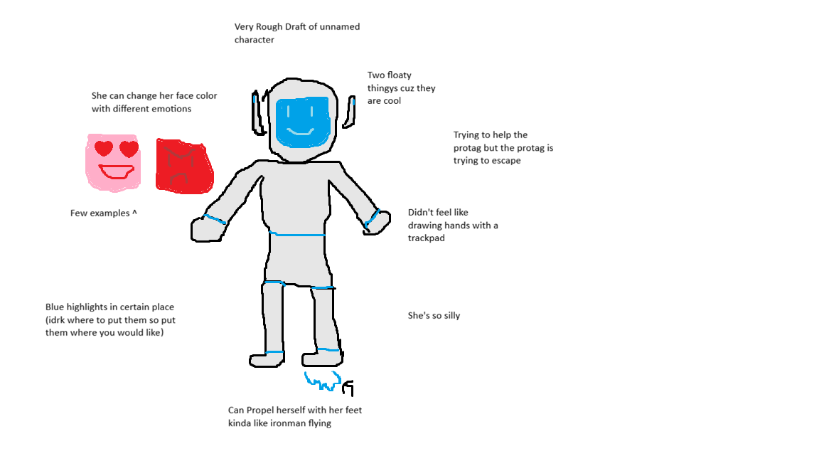

03/24/26 Archive
Block 2 to 3 (What I Did): (LAST UPDATED: 03/23/26)
- Sprite Work:
  - I made a “broken tile” that will likely have no collisions and be able to be passed through. This could be a small indicator of a *possible* hidden area. It would function kind of like Super Meat Boy’s secrets hidden behind tiles. I sent it to you guys.
    - Just noting that the reason why I also send the Piskel file is in case you guys want to make edits before you implement them. Just saying.
  - I made a placeholder checkpoint and sent it to you guys. It has a small animation that transitions it from red (not touched) to green (touched and working).
- Unity Engine Work:
  - I added some more spike gaps to level one.
  - I have an idea on where the first checkpoint should go.
  - I need more traps (and therefore sprites) because I plan on transitioning (at the point where I finished in level one) into different traps in order to showcase all of the platforming challenges the game has to offer.
- Important Notes:
  - Just thinking about the future, I think a lot of what we plan on doing is completely unfeasible. Just thinking about the timeline, I think I have made a lot of good progress on level one, but there is a lot more spritework to do. If we want good sprites, I can’t be doing everything/taking every suggestion or idea into account. We still need more traps, paint, pause screen, checkpoint, menu, maybe new tiles, and more. This is just spritework. It’s already hard coming up with ideas to make actually interesting levels, challenging levels, and actually building out the tools to make said levels (i.e. the tilemap that I made earlier that took way too long to make). My progress is slow, I don’t have all the tools right now to make the levels, and I am essentially relying on myself to make the levels because my pace with sprite making determines my pace with level making. I genuinely am clueless and there is just a lot to do. I just don’t feel like there is a lot of collaboration right now or the progress is just slow for you guys (which is fine). I feel like I am relying on myself for all of the level creation stuff right now and just would like to know if any of you guys can help me out. With progress on this stuff. I need to know you guys aren’t goofing off or anything. Maddie, you can help with the spritework if you want to. I am not opposed to that. You clearly have good ideas, we just need to implement them. I just need to know that good progress is being made on your guy’s end because I have a lot of stuff to do right now if I am to entirely do all of the level creation and spritework. I just need some help/updates. If you need something from me, just tell me in the notes below.
  - Please make sure you are using your time wisely. I have been grinding my ass off everyday to the bell and have been crunching everything as fast as possible and things still don’t feel feasible.
  - I am honestly clueless on what exactly he wants on the Trello. I have always archived and documented progress on this document on what I have been doing (which is primarily progress on level one and some spritework). Can one of you guys add some more detail to the Trello and stuff? I am clueless.
  - Overall, just please keep me updated on this stuff. I want to know if things are going well and if we could actually build off of each other each block since it feels like I am entirely relying on my own progress on a crap ton of things to actually move forward and it doesn’t feel like I am getting any help with it. Just keep me in the loop.
- Notes for 03/25/26: Overall, I am going to continue through level making and sprite making to the best of my ability (as I don't want to completely just do sprite making right now). If I need something coded or start coding something new, I will tell you guys. I understand that the mechanics are the most important right now, thank you guys for working on that. I will help out where I can with coding (especially if I have any new ideas) as I assume you guys will do the same in terms of level creation whenever you get the chance to.

Block 3 to 2:
- Essentially rn Liam and I are trying to collaborate on making the paint mechanic (main mechanic of the game feasible I suppose I could try to make some sprites to help but that would slow down the coding (aka any traps/moving objects/checkpoints) unless you want to code them yourself work has mainly been slow for us because making paint work is just a little difficult (we are making a new branch today to test some of the ideas we talked about) I have a lot of ideas for levels but a big part of level making is having the mechanics of the game working which is probably why we haven’t been working on making the other traps as much (though lasers and a saw would be easy though lasers would be the harder of the two since they would probably need to blink before activating to make it more fair if you want to try and make them) and also keep in mind that for now it is ok to have placeholders I just wanted to make sure that we still knew that we were gonna be making them (if you want I can go home and work on the engineer character at home for a few nights). Also for the pause menu we could honestly just make it really basic for now and spice it up a bit later, same thing with the main menu. The main menu I may decide to move it up a bit but yeah.
- Honestly no idea what he wants from the trello either but I think I will make it more clear on what is happening with it by deleting the “done” part might delete the in progress column later but rn it is mostly stuff for throughout project so unsure if I will just rename it or not
- Also Liam keeps bluescreening so it is slow with that too.
- new branch for painting tiles
  - beautiful red, green, and orange color sprites now exist, not fully used yet
  - figured out how tiles can get painted, see GameManager script, Tile (6), and GameManager object in hierarchy
  - paint tools needed for proper painting
- Working on checkpoint :3

03/25/26 Archive
Block 2 to 3 (What I Did): (LAST UPDATED: 03/23/26)
- Spritework:
  - I made a simple buzzsaw launcher with no animations and sent it to you guys.
  - I made a sprite for a buzzsaw and sent it to you guys.
    - I don’t know if we want or need animation, but I have both sprites for this trap. The idea is to have the buzzsaw centered on the buzzsaw launcher so that it can eventually launch or move in a single direction until it hits a wall (it dissipates). It is meant to function as a trap on an interval that moves in a continuous direction and makes you die or respawn when hit. I will see what I can do to set it up later, but I am not familiar with adding the sprites and starting the code. Can you set me up with some code or something so I can use this trap or get it to work myself?
    - If you need me to do animations for the buzzsaw spawning in the launcher or dissipation just tell me what you want and be descriptive.
  - I also made and sent a trap for a floating buzzsaw with a slightly different model.
    - It can be used as a uniform/symmetrical mid-air obstacle.
    - This trap could also have a rotating animation eventually if need be. Just tell me what to do with this stuff.
    - This version of the buzzsaw is essentially meant to be a floating spike of sorts.
- Unity Engine Work:
  - I created a flat plane after where I ended yesterday as well as a pit of sorts with a few spikes at the bottom.
    - I have more ideas for what I want to add to these areas (and possibly previous ones) for this level. I just need more trap options to help ramp up the difficulty and to diversify the game slightly.
- Other notes/bugs:
  - I think fetching worked properly I hope.
  - I spent like two minutes looking into possibly doing another tilemap (with spikes) but it honestly is looking like it would take way too much time to figure out. I also think the spikes are relatively easy to copy and paste manually right now compared to the actual tiles themselves.
  - I moved John Egress next to the pit to mess around with it. Is the respawn for him linked to where he was before or can it be moved easily with him? You DON’T have to do anything with this, I just want an answer. I can work with him just spawning there and not respawning where I move him at least for now.
- Future Work Notes:
  - I plan on extending this level a little bit more and possibly adding one more trap to it. The buzzsaw launcher is probably a much more complicated and advanced trap so we can leave that for later for now. Right now, I just need help getting the floating buzzsaw set-up and I also plan on making one more trap type for level one to make it a bit more interesting. Once we have these traps done, I can make significantly more progress on the level and possibly finish the shell of it. Checkpoints, background, and the completion mechanic are probably for later if you guys agree with that. I am just talking about the shell of the level itself. Overall, I plan on making much more progress later than I did today (as there wasn’t a whole lot I could do without a lot of the stuff set-up). Getting at least the floating buzzsaw set up would allow me to make a lot more progress on the level while I work on the final trap idea/sprite to further diversify this level and finish the shell of it. Just make sure you get back to me on this as well as the other two questions I asked in the sections above. I will help with coding where I can (especially with level-creation/trap related stuff), but you guys seem to be doing well with that (with the paint mechanics and checkpoint system) and I still have a lot of progress I can make with what I am doing now. Just say what else you need from me if anything.
- Notes for tomorrow: Follow the instructions below on making the buzzsaw sprite function and work (and look correct to). The sprite has already been added to my branch and it is in the sandbox scene. If time permits, update the level (one) with new ideas and more traps accordingly. Likely no spritework today.

Block 3 to 2:
- Answers:
  - Try looking into what the spike does, maybe mirror the spike?
    - will probably need to look at gamemanager.cs or smth
    - see the sandbox scene in your branch, there should be a buzzsaw there you can look at (floating)
      - all that needs to be done for this one is a script to spin it, and then you can make it a prefab (if you don’t know how to, i can do it)
      - the moving saw can be based off of the prefab, just change the sprite, however it's going to need a little extra code than just spinning
  - The buzzsaws can just rotate, yeah.
  - The respawn point is found under the GameManager object in the hierarchy, move the point as you see fit (or not)
- maddies vm shit itself (fatal error)
- btw the spikes at the bottom of that pit are kinda unfair

03/26/26 Archive
Block 2 to 3 (What I Did): (LAST UPDATED: 03/26/26)
- Important Update For the Future:
  - I think it is reasonable to start the slides for the upcoming “Midterm Presentation” next week on Monday (at least a little) to have them completed by April 14th. The goal is to not work on it over break so we can discuss details on how much we are doing later. This is just a reminder so we can complete it and also not have to work on it over break. We will get more details on Friday apparently. I would like to have everything done in class on that Monday before it (April 14th). Also, Maddie, I would like to have you come to my block again to talk about the stuff you guys were doing in your block a little please.
- Bugs/Issues:
  - Bad lag issue when loading with the new tiles (thank you BTW). Can you help, Liam?
- Unity Engine Work:
  - I made a script for the “buzzsaw” trap rotation and applied it.
    - I think the hitbox is good.
  - I made a variant, that is bigger, to use.
  - I added a few buzzsaws to my level (or level one).
- Concluding Thought(s):
  - Liam, I need you to help me fix the lag if you can. Everything is already saved and committed from my progress today. All I did was leave Unity Engine open.
- Future of our Project for 03/27/26 and on:
  - I plan on making significantly more progress on level one now that I have another trap. If I come up with any more ideas to flesh out the traps or other aspects of level one, I will list them here. Other than that, I might work on the current sprites we need here and there. Once I ask you guys about new traps or decide on anything myself, I will make a sprite to be added to the project (which you guys can probably do and approve) and do the same thing I did today if need be (as I think I got the hang of the scripting and coding aspects of the traps themselves hopefully).
- Important notes for 03/27/26:
  - I will add checkpoints where they are needed when I see that they are ready. Thanks for working on the character stuff. Also, thank you for the presentation thing (and hopefully he allows it).

Block 3 to 2:
- i love scaring your computer to work
- maddie’s computer now fixed
- I’ll ask tmr if I could go up block 2 (I also want to see some of the other presentations so it works out and I also don’t like gym lol)
- liam
  - started making a different way for paint tiles (could be useful in the future, idk)
  - will work on paint effects soon
- Finished Checkpoints Liam said he would merge them to Eten branch
  - I am gonna work on getting the player animations done (I could just move the code over to the finished character later)

03/27/26 Archive
Block 2 to 3 (What I Did): (LAST UPDATED: 03/27/26 & ARCHIVED)
- Future Progress/Work:
  - “Midterm Presentation” is next
    - Maddie, please ask about coming down whenever the presentation day is.
    - The presentation is due Tuesday night, right?
      - Ideally, we should have 5 days (and 20 min for Thursday possibly) in class to work on this. We should be able to get it done without having to work at home or during break if we focus on it beginning next week.
      - We should try and focus on it on Monday through Thursday (even for the brief period we have then) and finish it on Monday in class or possibly Tuesday if need be (as I will likely set up a note sheet like we did for our last presentation).
    - The only thing I am questioning is the “demo” bullet for the presentation; Do you think we have enough of a game or can set something up real quick? Is my current level progress good?
      - Things to Tidy before Demo:
        - Checkpoints - Necessary
          - Please merge the branch and add checkpoints where they are needed. Maybe like one or two.
        - Traps - Up to You (if you want to make the demo/our progress look better in terms of levels)
          - You can add traps in small areas near the beginning to add a little difficulty if you want. You can also add traps to the pit section.
        - Background Tiles - Not Necessary
          - I am still not entirely sure how I feel about any of my background tiles yet. Not even sure how they look in the game yet lol and I am doubting how good they will look right now.
        - Player Character - Not Necessary
          - We could add running animations to the character at the very least, but that will probably take a long time since we don’t have much time while working on the presentation and stuff. The new character sprite is far off in priority right now.
      - I am noting these things mainly because I think cleaning up before the demo is a TOP PRIORITY considering we won’t have a whole lot of time if any with working on the presentation and stuff. These are things to be done TODAY. Keep me updated and I will note where everything is at later. I think I have a pretty decent foundation with the level and everything all things considered.
    - There still is a small check-in on Tuesday so just note that.
    - I will plan everything out in terms of what we should do and start setting up the slides on Monday.
  - Note about Unity for the Future and Demo:
    - The section just at the bottom of the pit (literally just a floor right now) is probably where things will stand for the “Midterm Presentation” demo. I plan on adding another trap to finally flesh everything out. The flat section after the pit will likely be the final section. I will have a little progression there with one more trap (that is new) probably. In terms of traps in general, everything is subject to change (even in earlier parts of the level) as I consider new traps and rethink about stuff relating to the old ones. - Project, fire trap, and making level easier
- Progress Today:
  - Unity Engine:
    - I added some more buzzsaw-related traps in areas and laid out the tiles for the pit section.
  - Bugs/Stuff:
    - Gotta hope the fetch worked. I got “astral projected” in my VM.
- Collective Notes & Plan for 03/30/26 & Later:
  - You guys can work on and continue on whatever you want for now. My plan is to start the presentation on Monday and just record my progress with it and stuff. I should have a better gauge of what we need to do and when/how long by then. I also plan on possibly adding something small here and there in terms of level one stuff and Piskel spritework. I think I will have a better idea of how to do the former and latter by the end of Monday. Just keep working and I will tell you how things go and stuff. We do still need to prioritize the presentation during class time so we don't have to do anything outside of school (and of course you guys can continue stuff with the project, just note the importance of getting the presentation done with the classtime we have by the due date). All of the planning with this stuff should be done by Monday. Otherwise, I will keep you guys updated.

Block 3 to 2:
- Presentation is due tuesday night
- Maybe i could see if we can get a packaged release demo type thing for midterms that can be shared with everyone to run on their computers (no admin needed, nor unity engine)
- you have checkpoints now yippee
- maybe chill on the precision platoforming (that new area with the tiny saws needs very precise movements)
  - also the spike staircase is brutal
- Animations almost done - Maddie :3
  - Oh also I lowkey forgot to ask I was raising my hand and then he went into articles and then I was gonna ask at the end of class but I forgot
    - If I see him on my way out I will ask

03/30/26 Archive
Block 2 to 3 (What I Did): (UPDATED: 03/30/2026 & ARCHIVED)
- Important Things to Note:
  - Progress is definitely speeding up, I got a lot done today.
  - I decided to focus more on the capstone project itself today as it was Bixler’s recommendation (especially since there is a check-up tomorrow).
  - Make sure the capstone is ready tomorrow in terms of the “Trello” and “Github” things.
    - Inform me if there is anything important you need to tell me.
  - I have a new idea for a trap: “Fire Spitter.” Essentially it is a block that shoots fire in a 1.5 block radius above it (depending on how it is rotated). This will likely be the last main trap for level one and it will be used in section three of the level.
    - By the way, anything before the first checkpoint is section one, after and before the next checkpoint is section two, and the last checkpoint and on is section three. The level finish point will be after. This level feels like a good starting point for players with just the platforming mechanics.
  - Level one is going good, just need to finish the last part of section two as well as section three (which will use the new trap). I should have time to get the sprite done as I finish section two so I can send it to you guys and start section three right after so there won’t be too much waiting.
    - If need be, as I finish the sprite, I could always just start the framework for the section and just leave open spots for the new trap to be placed.
  - Last note is that if you guys think that the buzzsaw staircase before the pit is too unforgiving (especially at the top), you guys can delete/move stuff to tone down the difficulty.
  - I realized the logo for our game uses colors not in the game. I figure the whimsical colors and font can work well for our protagonists palette to help the logo still fit in the game while also allowing us to still use the grey facility theme/colors.
  - I am reworking/reusing some of the slides (like the developers and the title slide) as well as copying the theme as it makes sense to reuse them again instead of remaking everything again. All of this stuff looks good already.
    - I am also clarifying that I copied the title slide from the unused version as I think there is no reason why it can’t look grander or more stylized instead of simple and modern like the newer (submitted) version we used in the “Project Pitch” assignment.
- Unity Engine Progress:
  - I finished up making the first section look good as well as the first half of section two.
    - In these areas, I added a little bit of buzzsaw decoration to the very beginning room as well as toning down the difficulty a bit and adding more really easy jumps (to make the areas feel more fleshed out).
    - The area in section two I think is much more forgiving as well as the spike staircase in section one.
    - Everything before the pit part in section two should be done. Of course, everything is subject to change (but I think it looks pretty good, you should try it).
- Piskel:
  - I started making the sprite for the new “fire spitter” trap, although I made little to no progress today. I should make much more progress tomorrow.
- Midterm Presentation:
  - I didn’t do much, I just created the template (which will be the template that we scrapped from the previous “Project: Proposal” assignment.
    - I like it already, it fits, and it should save us some time.
    - I might change the colors around to match with the “containment facility” aesthetic.
  - I shared it with you guys accordingly.
  - Not gonna lie, but I essentially did like nothing with this (lol), but I did share it. Didn't even finish where I wanted the title slide to be, lol.
- Final Thoughts/Things to Note for 03/31/26: I will likely just work on just the presentation after he checks in with us and go update anything we need to. After the midterm and stuff, I will make sure to finish up some sprites (fire spitter, pre-painted tiles, finalizing the background tiles eventually, main character eventually, and other traps as we progress) and finish level one (at least the shell and eventually all quality of life stuff) and do the same with all future levels as we continue the project. I also plan on adding the moving platform to future levels when that’s done. Just keep me updated on anything important. Make sure Maddie checks in with Dr. Bixler.
- FINAL FINAL NOTE: Just make sure the project and everything relating to it looks good for the check-in tomorrow. Tell me if there is anything I should know for that and if it is good.

Block 3 to 2:
- Liam’s computer decided it really didn’t want to do work
  - so i took it out back, its fine now
  - started merging changes from main into other branches to keep up to date
- I uh I uh I finished animating egress YEYYYY!! :3 :3

03/31/26 Archive
Block 2 to 3 (What I Did): (UPDATED: 03/31/2026 & ARCHIVED)
- Midterm Presentation Notes:
  - As of yesterday, I formatted all of the slides in a nice and neat way (with one theme and titles for every slide), added the slides (and slightly edited) the ones we could copy and paste from the previous presentation (specifically the title, developer, and thank you slides), added transitions, and made Liam the owner to submit.
    - Feel free to change any of the things above, but I think it is pretty good already. Just tell me if you do.
  - Who is doing what?
    - The title, “The Developers”, and “Thank You!” slides are already done and converted.
    - I also added/reworked the entire theme with decorating and stuff as well as transitions.
    - I think it is fair that I only do two of the remaining nine slides. I plan on doing the “Current Progress - Level-Creation” and “Current Progress - Sprites” slides.
      - You guys can decide what slides you want to do and assign them to yourselves accordingly.
      - All of this can be subject to change as certain slides might need more than one slide to hit on all of the points we want to and I might add something here and there to enhance the aesthetics of the slides (maybe, if I have time or think it is needed). Some of the slides are also not really going to be full slides as well (like the “Demo” slide which will mainly be an actual thing more than a slide).
  - Maddie, ask Bixler about coming with me to present.
    - If yes, we can divide up what slides we will present accordingly on April 13th (Monday).
  - Keep me updated if anything is wrong.
  - I didn’t really work on the “Midterm Presentation” today because I already worked on it for over an hour yesterday and I think I can finish my part tomorrow.
    - On Monday, I plan on making a Google Document and sharing it to help with the presentation again (like I made for the previous presentation).
      - It is kind of like a script. You’ve already seen it before from the previous presentation.
      - Liam, make sure you give me instructions on the demonstration itself if needed so me (and possibly Maddie) can present it.
  - Not sure if time will be an issue or if he cares about it. We have twelve slides currently (although they are not all done yet). It’s probably fine, but it’s just something to note. You guys also might add slides later if you need to as well (as the twelve slides set up were just what I could come up with/expand on from the bullets he gave us in the presentation’s assignment on Google Classroom and I also don’t know how much info will be needed for each slide as some slides might need more info/slides than others) and I am pretty sure that the live “Demo” is also included in the presentation’s time too.
  - I plan on having my slides done on this Wednesday in-class and the script thing done on the Monday after Spring Break in-class, although it depends on if I finish my slides on this Wednesday (so my time on them might bleed into the Monday after break). Please try to get as much as you can done as soon as possible so you can add it to the document (script thing) I will make on Monday yourself so we can have it when we present in our respective blocks. This is meant to help each other present each other's slides in our blocks. It would be nice to have the script thing done before school is over on Monday so we don't have to worry about it while the History stuff is going on and so I can practice and print it. I will give you guys more details on this when I make it on April 13th.
  - Sorry for writing so much, it just helps keep me organized.
- Check-In Notes:
  - Everything was good for the check-in, just a couple of things:
    - You have a good idea on what a demo will look like, right? He asked about that and I think you had a good idea, right Liam?
    - Hypothetical computer destruction question. We would be fine if the computer were to break, right lol? Is everything pushed to GitHub properly? I thought it was, I am just making sure.
- Unity Engine Notes:
  - If my progress wasn’t saved properly, can you fix it? Just tell me if it was good, what happened, or how it went. I thought I fetched properly, but I am not sure.
  - I finished the pit part so that should be good.
    - I added primarily buzzsaws to it as the main trap.
    - It is purely a drop-based section (with no jumps).
    - I added a checkpoint right before the pit (essentially making the pit its own section). There are a total of four sections in level one now.
  - All of this now adds more to do with the demo.
  - I have a request: Can we please tone down the slipperyness of the character’s movements. I know you guys want the movements to be smooth, and they still can be, but in order to make the platformer we want to make in the time we have, we have to focus on smaller scale levels with a lot of traps (with trial and error being the main focus). It is incredibly hard to make a platformer with only basic movements (no dashes and such) and still have the character be slippery and for the game to be reasonably hard. All I suggest is making the character like 25% to 50% less slippery (probably a happy medium or around the 25%). I feel like it would make a lot of the difficulty not be as bad and for the game to require a little more precision. I don’t think we have the time (and resources) to make a fully fleshed out platformer that doesn’t lean at least into a bit of precision.
    - This mainly comes from Ryan trying to play level one.
- Piskel Notes:
  - I continued working on the “fire spitter” trap.
    - The base tile is done, I just need to add the fire sprite (and possibly an animation to the fire itself if I want to; I will add an animation eventually).
- Notes for 04/01/26:
  - Work on your two slides. If you get time, decorate/patch-up any slides to make them look better and possibly do more slides. Focus on the slides and no work on the capstone itself. If the slides aren't finished by the end of the block, just set a reminder to do them during break and if necessary, first thing on Monday (April 14th) before you make the and work on the script thing for the presentation on Tuesday.

Block 3 to 2:
- Answers:
  - 1. Yep, I plan on seeing if I can package the project as an exe for distribution to classmates so that each of them can run it on their own (without admin or unity engine installed, i hope)
  - 2. As long as you commit and push at the end of class or when something is done, you should be fine if your computer breaks.
  - 3. Your progress seems to have been saved. Again, as long as you commit and push, you should be fine (also remember to save the scene with ctrl s)
  - 4. I can try and test different slipperyness values.
- notes
  - please only press yes on unity scene recovery if you really think you lost data, might need to add the recovery folder to the gitignore
- liam
  - added a setting for slipperyness, was set at 0.8f, now is 0.5f. feel free to change it to how you like it
    - maddie decided on 0.5f while i fixed her computer
  - speed boost that temporarily increases move speed and reduces if the player is touching the ground and not on the paint (not implemented (internalized idea (internalized parenthesis))
    - reduces faster on the ground, slight reduction in the air
    - this is me planning the speed paint

04/01/26 Archive
Block 2 to 3 (What I Did): (UPDATED: 04/27/2026 & ARCHIVED)
- Unity Engine:
  - Nothing is working with the project. I have no idea why the scenes aren’t opening properly and everything. This is a HUGE issue as whenever I try to look at the scenes they’re all empty. I just wanted to test out the new stuff. My bad. All of this happened after I fetched.
  - I suggest not working with our actual Capstone much at all unless it is absolutely necessary for our “Midterm Presentation” assignment. I only spent 10 minutes roughly on it so I suggest you do the same or less (nothing more).
  - I just tested out my level with the new movement in Unity Engine and here are my thoughts:
    - I think the movement is much better and handles a lot better.
    - What do you guys think, is it still too hard?
  - Since tomorrow is a normal half-day, I suggest we make the most of the extra time we have. Just work on whatever you want relating to the capstone or the slides. I may or may not be here tomorrow, so I will keep you updated on that. If I am not, then just let me know what you guys did.
  - Regardless of the schedule change tomorrow, I suggest we keep our plan for today the same and follow what Dr. Bixler put on the whiteboard today. That is a good idea.
  - I didn’t edit anything, but the VM actually did crash. I am not joking. Doesn’t matter though.
    - I preserved a copy of backups. I don’t think it matters though.
- Midterm Presentation:
  - I worked on the “Midterm Presentation” assignment for 45 minutes.
  - I completely finished my “Current Progress - Sprites” slide.
    - Note that something like the tile randomization would be mentioned in the “Current Progress - Scripts” slide as it relates more to the script(s) themselves rather than the tile sprites.
  - I completely finished my “Current Progress - Level-Creation” slide(s).
    - I added a second slide for this topic to show a whole image from level one.
  - Tell me what you guys think of the three slides I made today.
- Piskel:
  - After midterms, when I make the background tiles, the tiles will probably end up being just darker versions of the floor tiles. To help mitigate this, I am making a new placeholder called “Bubblegum Egress.” This is because I will probably end up making the background tiles before Egress herself.
  - I made a new, bright placeholder and sent it to you guys. You might want to switch it soon, but I guess it doesn’t matter until the background tiles are finished. The background tiles will be finished shortly after the Midterms so do with that what you will.
- Other:
  - I doubt it is a problem, just check to make sure the GitHub Repo and Trello are good by the “Midterm Presentation” day as he will be checking that.
  - Make sure you answer my questions/notes today!
- Note(s) for Midterms and/or 04/02/26:
  - If we get time tomorrow for anything, focus on the “Midterm Presentation” slides & possibly the Capstone Project itself if you want.
  - I will share the script thing on Monday and we can make it then to help make the presentation on Tuesday easier. This will likely be the focus on Monday, April 14th if the slides are done. If the slides are not done, just make sure to do them quickly and then get to the script thingy please. The Capstone Project itself should only have more progress made on it if it is very important/an emergency. We can get back to the Capstone Project after Spring Break.
  - I will also figure out who is presenting what (on Monday, April 13th), Maddie, if you are still up to help me and you can help me present on Tuesday, April 14th.
  - I think I am good with my slides for the presentation for now. I will likely check them during Spring Break.
  - I will keep you guys updated on what I do tomorrow (like usual), but it should essentially be a day to work on whatever you think we need to. Ignore everything I said about not being here tomorrow. I will be here to work on whatever and give you guys notes and stuff like usual.
  - I will likely just get a head start on everything I was planning to do on Monday so we have more time to prepare for our presentation on Monday. I will keep you guys updated.
  - I plan on working on the sprites more tomorrow if I have time (since I will be doing some of Monday's work tomorrow to get a head start). That way, anything I do after I am done with project related stuff won't be dated and I can still make good progress/get work done. I will share anything (if it is done) accordingly.
  - I will plan on what to do accordingly around Midterms and stuff as well before the end of the block tomorrow.
  - I will fix the difficulty with stuff after Spring Break/Midterms.
  - Make sure you note the difficulty issue of trying to make the levels balanced in the obstacles we faced when making the project slide in the “Midterm Presentation” assignment.
Block 3 to 2:
- we delted all the file from all branchs, glhf ♥️
- I frew up on the projec an dlted th e slidsho
- Your slides look good 👍
- our computers are having a great april fools day
  - maddie’s vm crashed and it broke unity hub
  - liam’s vm decided that internet was not a necessity
- the level seems alright, maybe tone it down on saws or smth
- we worked on the slides
  - liam did the scripts
  - maddie did the about the project and reach goals
- Fix yo bug twin like what am I looking at here twin
- 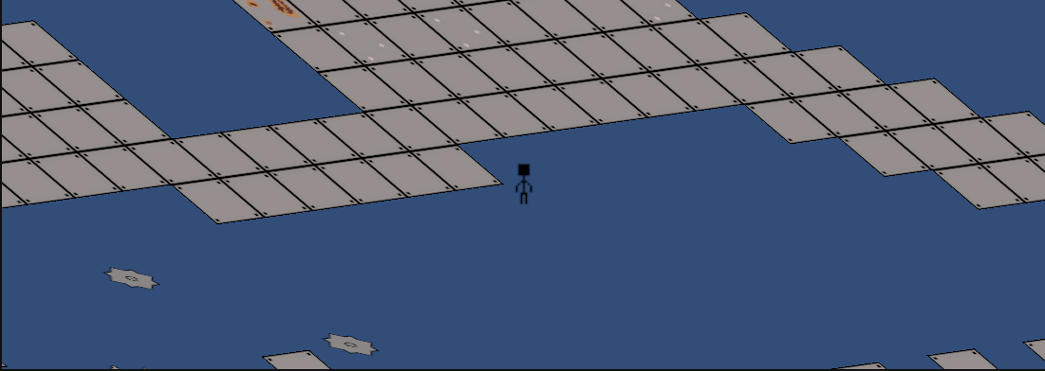
- 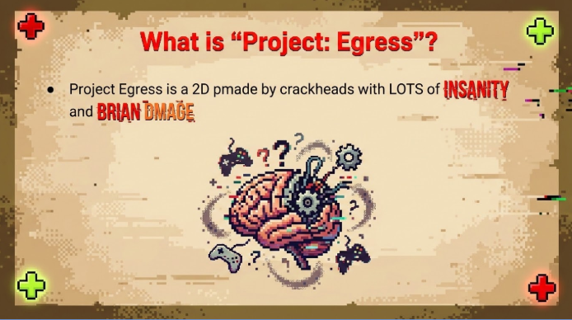

04/02/26 Archive
Block 2 to 3 (What I Did): (UPDATED: 04/02/2026 & ARCHIVED)
- “Midterm Presentation”:
  - He added a note today to “note who made each slide in slide notes.” I put what slides I did (specifically my name) in the speaker notes of the five slides I did.
  - I made a “Notes for “Midterm Presentation”” document like I said I would.
    - Just follow the formula that I did with writing anything down that isn’t explicitly stated on the slides you created or just anything you wanted to mention not on the slides. If there is nothing, just put “N/A (All Info on Slides)”.
    - I did my part with this today and shared it with you guys. Make sure to get it done by the end of class on Monday, April 14th so we can practice (or at least for me).
    - Make sure you put in your information in the “The Developers” bullet whenever you guys get to working on this document.
- Piskel:
  - I didn’t get to do anything today, but I did leave a note for the future of what I will be doing around/after Midterms.
- Unity Engine:
  - I didn’t get to do anything today, but I did leave a note for the future of what I will be doing around/after Midterms.
- Notes for 04/13/26 & 04/14/26:
  - 04/13/26
    - I will mainly review my slides and/or your slides in class (to be prepared for the presentation) for a little bit (since I have my parts of the slides and document already done). I will make sure everything on my end is fully done, ready, and I feel comfortable with presenting. This includes figuring out who will present what (which I will write down on this document likely) when you come, Maddie. Make sure you ask the appropriate teachers.
    - If I get time to, I will work primarily on sprites.
      - Some sprites to work on include finishing the “fire spitter,” finalizing the background tiles, finalizing the pre-painted tiles, making a goal post or ending sprite, and possibly getting started on the player character. The rest of the sprites we will make up as we go along (such as new traps) or are lower priority (such as the title screen, UI, or pause screen).
    - I also might spend my time, if I have any extra time, working on finalizing the difficulty in the first three of the four sections in level one in Unity Engine.
  - 04/14/26
    - Presentation Day!!!
    - Maddie, make sure to come down during Block 2.
- Notes for After Midterms:
  - The following is a list of stuff I will likely be working on or stuff we can work on doing together (which I also note). You guys probably know exactly what you need to work on right now. I just figured I would mention this so you guys know:
    - In terms of sprites, my highest priority sprite right now is the “fire spitter” trap as I need it to finish level one. I will try and get that out as soon as possible. To finish level one, I will also try to get done the background tiles and some sort of goal post in terms of sprites. The new trap is needed primarily to finish the shell of the level. Next on priority (medium) is the pre-painted tiles so we can make the shell of levels after level one as well as level zero. This is primarily lower in priority because level one is already really close to being done. On lower priority things I would put the UI/Hud, the title screen, the pause screen, and the player character. I will get those done at some point later down the line.
    - In terms of level-creation, my goal is to finish level one as soon as possible by doing the things listed in the bullet right above. Then we (or I) can move on to the future levels or level zero. Level zero will probably be my next level I work on after level one.
    - All I need from you guys is to possibly help me with the mechanics of things for the sprites I make down the line (such as the goal post/point or other traps). I can also work on this stuff (in terms of code) too if I feel like I can or you need me to.
  - Some of the things above I might get started early (on Monday, April 13th) if I get time to (like I mentioned in April 13th’s respective bullet).
- That is all for now, have a good break. Thank you guys a lot for everything!
- Final Note(s) from Today for Later:
  - Make sure enough images are added to the “Midterm Presentation” like Dr. Bixler wants. They could be the code, game itself, the sprites, or anything else. I will check anyway when I check everything over on Monday and possibly add more to my slides if I think I need to. Just make sure you (Maddie & Liam) do the same.
Block 3 to 2:
- yeah we did nothing at all
  - maddie and ed decided to trade wrappers and eggs using my desk as a trading center (and adding to my trash pile)
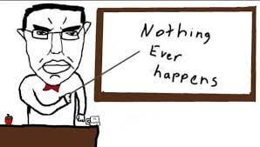
- something happened
  - we worked on the challenges, high priority tasks, and scripting slides
  - we will need to add images to slides

04/13/26 Archive
Block 2 to 3 (What I Did): (UPDATED: 04/13/2026 & ARCHIVED)
- “Midterm Presentation”:
  - In terms of progress on it, I believe that my portion of it is done. I did end up making the following edits though:
    - Minor capitalization/grammatical errors on one or two slides
    - Added “floor bumps” as one of the “Scripts - Bugs” difficulties
    - Added an image to the “Challenges” slide
    - Other minor tweaks to the “Challenges” slide
    - Other small tweaks to the rest of the slide captions and such
  - “Notes for “Midterm Presentation”
    - I already added my portion for this regarding information on my slides a bit ago so that should be good.
    - Make sure you guys add information about the slides you did (if needed, otherwise, just put “N/A”).
      - Just a reminder to also do this for your portions the “The Developers” slide and the “Challenges” slide as they both already have text under them from my portion.
  - Plan for Presenting (if possible):
    - Maddie, I just need direct confirmation that you are good for tomorrow, if yes, the following is a plan for what slides we should present in class (if you can, if no, I will present them all with the notes on the notes document from the previous unfilled bullet):
      - “Project: Egress”/Title/Intro - Ethan
      - What is “Project: Egress”? - Maddie
      - The Developers: Liam - Ethan
      - The Developers: Ethan - Ethan
      - The Developers: Maddie - Maddie
      - Technologies/Languages Used - Ethan
      - Current Progress - Scripts: Notes - Maddie
      - Current Progress - Scripts: Video - Maddie
      - Current Progress - Level Creation - Notes - Ethan
      - Current Progress - Level Creation - Image - Ethan
      - Current Progress - Sprites - Ethan
      - Challenges - Both
      - High Priority Tasks - Ethan
      - Reach Goals - Maddie
      - Tech Demo - Maddie
      - Thank You! Any Questions?/Conclusion - Ethan
    - Feel free to edit any of this, Maddie, if you think you need to or you work on slides I don’t yet know about. I think this is a good plan for now if you are able to present with me (since we didn’t have a plan last presentation and I just kept going, lol). If you need to edit this, I would prefer you do it by the end of the block.
  - Final notes:
    - If it is okay, I think we should try volunteering to present as soon as possible, tomorrow. I will at least do that in my block. If this helps to allow you to join me in presenting tomorrow, Maddie, then this is very important. If you still can’t join me or anything, then this is just for me.
    - We seem to know exactly what we are doing after presentations and we have a clear plan on what we are doing so I don’t think I need to update any of that/the stuff we need to do after the “Midterm Presentation”. Although I didn’t end up getting to work on the project itself today, I think we are still on track and have plenty of time to do everything we need to (at least for now). I also have the “Notes for After Midterms” bullet on the previous archive, too.
  - Notes for 04/14/26:
    - I will try and present as early as possible tomorrow and/or go first. Please get clear confirmation you can present tomorrow from Galea and Bixler. If yes, just state it here, Maddie. If you can’t, I will work everything out on my own. Please make sure you guys finish the “Notes for “Midterm Presentation” on any bit of information that would be helpful when we present each other’s slides (in either case regarding presenting). This should be everything important regarding the presentation. Just give me the progress/answers on the slides (should be done; I want to practice presenting any slides I will present tomorrow), the “Notes for “Midterm Presentation"" (should be done; I want to practice presenting any slides I will present tomorrow), on if you can present (VERY IMPORTANT), Maddie, and anything else you guys might have done in class today (like adjusting the slide presenting plan if you really feel like you need to, Maddie. Make sure to submit the slideshow if it is done, Liam. Make sure to push anything/everything to the repositories (and specify why if you didn’t) and update the task tracker (Trello) if needed. Anyway, we are presenting tomorrow (likely) so good luck.
Block 3 to 2:
- I mean I can’t get confirmation with Galea today anymore xd (Unless you want to accompany me to find her after school) (Bixler said yes tho)
- You never shared the doc for slide notes with us
- I decided to make some sprites for the paint selection
- Started prep for the video (debug variables and cleaned them up)

04/14/26 Archive
Block 2 to 3 (What I Did): (UPDATED: 04/14/2026 & ARCHIVED)
- Notes for Dates After Presentation(s) are Over or Whenever we get Time to Work in Class Next:
  - Let’s continue to follow our plan(s) listed out from 04/01/26 to 04/13/26 archives. This is pretty self explanatory and we have talked about this stuff a bunch of times already.
  - Before we get to this, let's just collect our thoughts from any of the comments about our project from during our presentation and gameplay play-test demonstration thing too. Both Dr. Bixler’s comments on the project itself and people’s comments during our presentation should be useful.
  - Essentially, both of these two points sum up everything. I am sure we all know what to do. I believe we will likely continue project stuff on 04/17/26 mainly with possibly some time in between or shortly after. Just follow what you/we have been doing and I am sure we will be/are good.

Block 3 to 2:
- Suggestions from play test:
  - Make saw hitbox smaller
  - Make level 1 easier (to frustrating for a first level)
- Questions for Aidan's project for 04/15/26:
  - “What are your plans with the upcoming policy in May specifically publishing a game playable for 16+ requiring an ID and for younger age groups requiring an ID and a Roblox + subscription?”
  - “Do you have any plans for an anti cheat (kick/ban inf stam, noclip etc.)?”
  - “Any plans on adding anything the player can grind emotes (ex. Can’t wait to meet you) or skins (reference or not)?”
  - “Any special LMS?”

04/15/26 Archive
Block 2 to 3 (What I Did): (UPDATED: 04/15/2026 & ARCHIVED)
- I only asked Aidan the second bullet from your questions, Maddie, and it was a dumb question.
  - Just ask Aidan later about his answers for all of the questions you had, we were a bit crunched on time today with/for presentations.
- Just follow the plan/ideas I posted yesterday (04/14/26) on what will happen later.
  - Nothing changed at all today, we just did more presentations.
  - I will keep you guys updated if anything changes.

Block 3 to 2:
- N/A

04/16/26 Archive
Block 2 to 3 (What I Did): (UPDATED: 04/16/2026 & ARCHIVED)
- General Notes:
  - Dr. Bixler sent the comments back at the end of the block and it looks like we are good to keep doing what we are doing.
  - I am currently going to work on some of the feedback from our playtesters (such as the difficulty issues).
  - I had less time today because we had one more presentation that was roughly 20 minutes.
- Unity Engine:
  - I committed “_Recover.meta - Assets” because it looked like I had to after hitting fetch.
  - Because I removed a bunch of traps, I added a little bit more of “buzzsaw decoration” to the level or in other words “unhittable traps.”
  - Because I removed a bunch of traps, I also added some tiles and filled in some gaps to flesh things out more or make things more interesting.
  - In terms of difficulty, I still don't want to make the game too easy. There will still be a tutorial level (Level 0) before this. I made the following difficulty changes:
    - I mainly focused on deleting unnecessary traps and not really moving or adding any. This only really applies to the starting floor right now (before the stairs).
    - I adjusted the mini jumps before the stairs to be more intuitive with the floatiness of “John Egress.”
  - I encountered the following bugs recently and feel free to fix them because I have no clue why they are happening:
    - “Floor Bumps” - For some reason, I don’t know if it is just the frames, but the collision in between each tile is occasionally causing the player to be bumped slightly upward. I noticed it after starting the level, but it went away after 15 seconds roughly. When I died again and respawned, it started again before dissipating. Please try to see what this is. This is the only way I have been able to consistently recreate it.
    - “Wall Jumps” - Collision between tiles on a wall allows for pixel-perfect climbing. Ask Maddie about this, Liam, as Ryan found it when we were play-testing the game.
  - I synced and committed at the end like normal.
- New Ideas to Possibly Implement Later:
  - “Teleporter” - I could work up a sprite for that. All it would be is just a system where if the player is on top of one it instantly transports to another one (possibly the same design or it could be designed like a transmitter & receiver tile(s)). This could make it easier to teleport back from secrets or allow us to not have to work around the base structure of a level and just easily have a new space to work with. Checkpoints could be added around them accordingly.
  - A Rework to “John Egress” - I like the floatiness of the character already. This is mainly about the animations. This isn’t entirely necessary because we will have a new sprite later, but this is just a thought as we might need it later with the new sprite. My idea is for the sprite animation for “John Egress” to stop/freeze when he is in the air. It just looks funky that he is literally running in the air. It would make more sense for his sprite animation to pause (at least in my opinion) as he jumps. This would definitely be used when we finish “Egress” herself. This would essentially be just a check to continue the running animation as long as he is on the floor.
- Notes for 04/17/26 and/or Later: I would say just to continue on anything you think is necessary in terms of mechanics (with painting probably). Maybe you guys could get to bug fixing or I could if I get the time. There are only a couple bugs I know of right now so it shouldn’t be too hard. I plan on maybe doing some sprites tomorrow for any of our ideas that we have come up with or anything we are in the midst of making. Not sure about what I will do with sprites tomorrow if anything. I know for a fact that I will continue to adjust the difficulty later throughout Level 1. If I get the time, I will work more on finishing the shell of level one (although that does require me to at least finish the “Fire Spitter” trap sprite. Anyway, this is just a collection of my thought process on where to go next. I will keep you guys updated.
- Notes on Block 3 Responses/Notes from Today:
  - Everything you guys did seems good. I like the idea of going back and forth with the character sprite. I will keep doing what I am doing with difficulty and keep moving forward with my ideas as long as they are not too difficult. Keep doing what you are doing. It all sounds good.

Block 3 to 2:
- I was thinking about having sprites for jumping up and falling down or having one sprite for both and just do like a squash & stretch thing like celeste does
- I had an idea yesterday (that Liam then stole and passed off as his own) about fixing both and that is having a script that connects tiles that are next to each other as it looks like both are caused by clipping into the line between the tiles
  - No idea if Liam is doing that today or not (he is)
  - in progress, not finished yet, remind me to try finishing this today as i committed to the first level branch and it breaks the game currently
- The next thing I am gonna be working on is the wheel for the paint switching (sprites wise) and also coding them in (except the switching paint part as well that isn’t done) but the animations will take a while to animate in Unity and such so it should be like half a week(?) of work
  - Afterwards I can help with sprites for the player and such if we just want to ping pong the file back and forth and collaborate on that
    - I might after school if I have time work on more art for the player character

04/17/26 Archive
Block 2 to 3 (What I Did): (UPDATED: 04/17/2026)
- General Notes:
  - We had tech articles like normal (so I started a little bit later than normal).
  - I worked mainly in Piskel today as everything is funky in Level 1 right now.
  - Liam, please at least fix the Level 1 tile issue because it is impossible to work with right now.
- Unity Engine:
  - I hope it fetched properly because it looked like something weird happened. It’s probably fine.
  - I forgot that everything is broken (so I can’t really work in Unity Engine right now).
    - FYI (Liam): I don’t know if this is intentional, but even with the broken size hitbox increase of each tile, there is still a tiny, but noticeable issue with “floor bumps” still.
- Piskel:
  - I worked on and fully completed the “fire spitter” today and I think the sprite looks really good.
    - I emailed it to both of you already.
  - I didn’t work on any other sprites today, but it’s probably fine. I got to spend time really fleshing out the “fire spitter” and making it look really good.
- Notes for 04/20/26:
  - Now that the “fire spitter” is done, all we need to do is actually implement it into the game. While I finish the shell of Level 1 (after Liam fixes the level one issues), can you guys make my new sprite a trap (as I don’t really mind how you work with it - as long as it is functional). I am sure you guys know what to do, just keep me updated. In terms of what I plan on doing, I want to finish the difficulty changes soon, then shift to finishing the shell of the first level (with the fire spitter), create a “level complete” sprite and finish what I need for the background tiles (if I need to change anything), possibly update the “checkpoint” sprite, and then fully complete Level 1 (of course without the finish character sprite as it can be done whenever we want). That is just my plan, all I need from you guys is to possibly implement the code for the sprites I make as I make them. I could also definitely help with that too if needed and I can help with any other code you might have if I don’t really have anything I can work on (if we are stuck on anything, etc.). Of course, everything is subject to change. Tell me if any of this is not feasible. I will do what I can, like I have been, and keep you guys updated every day regardless. Maddie, we can also both work on the character sprite whenever, especially if I don’t have any immediate thing to work on.
- Response for Block 3 - Notes:
  - Cool, thanks for kind of fixing that. I will continue to work on what I have been planning based on this document and whatever ideas come to mind.

Block 3 to 2:
- you should be able to play on your branch now??? idk was testing a lot of things

04/20/26 Archive
Block 2 to 3 (What I Did): (UPDATED: 04/20/2026 & ARCHIVED)
- General Notes:
  - I tried to work in Unity Engine, but I had issues…
  - No clue how to fix the issue, so the only thing I could really do was work on Piskel sprites.
  - I spent like 20 minutes thinking about background tiles and I am still not sure where I want to go with them yet. That will probably be the last thing we add to each level at the end. I will need more input from you guys when we get there down the line. I feel like that is a good place to leave them for now.
  - I fleshed out and finished more Piskel idea(s).
    - I started working on the new character sprite…
      - I am currently working on the idle/standing sprite. I will send it to you when I am done and you can tell me how you like it or what you want changed, Maddie.
- Unity Engine:
  - Nothing!!!
  - Liam, you made things worse. Everything started to slide through each other and they all had physics. I could barely even move the character, they just started levitating and moving at one frame per second.
- Piskel:
  - I made different teleporter sprites that should be linked together when used. One of them is yellow and one of them is blue. Repeating the same sprite throughout a level shouldn’t be an issue. I feel like having at least a delineation between which end of the teleporter you are using should be good enough. The sprite also has a slight gradient animation to be used whenever the teleporter is activated upon landing on top of it.
  - I sent the teleporter sprites to both of you guys in your email.
  - I started working on the main character's idle sprite. I will send the idle sprite when I am finished.
- Notes for 04/20/26:
  - I plan on working on adjusting the level difficulty for level one whenever you get it working Liam. Liam, please try and fix the issue preventing level one from being run (essentially) by tomorrow. I literally cannot do anything with level one right now without it breaking and I don’t want to make things worse. I feel like I am in a good spot/direction on where I want to go next and what I want to do. I will keep you guys informed on everything. The “General Notes” at the top details exactly how I feel about some of the stuff right now and what I want to do a little bit too. I feel like I am in a good spot right now. I primarily want to work on balancing level one tomorrow and working a little bit on the main character’s idle sprite in Piskel a little bit at the end. Please let me know how things go and make sure there are no issues for tomorrow, please. Thank you very much.
- Response to/for Block 3:
  - Thank you a lot Liam. I am going to continue with my plan (as stated above). I am sure you guys know what to do. Just keep me updated. I will keep you guys updated as well.

Block 3 to 2:
- The small bumps and wall jumping should be fixed now, no more singularity egress -Liam

04/21/26 Archive
Block 2 to 3 (What I Did): (UPDATED: 04/21/2026)
- General Notes:
  - My main focus was on working with level creation with “Level 1.”
  - I also spent a little bit of time at the end working on sprites.
  - I have all the specific details and planning listed below.
  - Keep me informed if you need anything.
- Unity Engine:
  - I worked mainly on balancing all existing areas of level one (and I have completely finished what I think I want to do with this).
    - Tell me what you guys think.
  - I also made the general layout of tiles surrounding the final room (with just the borders).
    - I didn’t do too much with this because I still need the “Fire Spitter” trap integrated.
- Piskel:
  - I made a (possibly placeholder) finish/ level complete flag to be used at the end of a level. It is very similar in aesthetic to the checkpoint flag. We can use it to transition from one stage to the next.
    - I sent it to you guys accordingly.
- Notes and Planning for 04/22/26:
  - I plan on continuing level creation with “Level 1” tomorrow if that is possible. All I need to finish the shell of the level is the “Fire Spitter” and “Finish Flag” done (but probably not transition mechanic yet as “Level 2” has not yet been made). Eventually, we can fill in the gaps with proper transition screens, a start screen, a level select menu, background tiles, etc. Right now, let’s just focus on the levels themselves. If it is a big deal, you guys can’t code what I need, or you guys need me to code this stuff just tell me and I can do it. I just would need some instruction on how to get this stuff integrated because I am not very good at it. Once the shell of “Level 1” is done, I can shift my focus onto whatever (i.e. more levels or tutorial, coding with any more necessary mechanics, etc.). Tell me if you need anything specific from me. Right now, sprites like the “Egress Character” sprite, secret coins, and other things are on the backburner and I will occasionally work on them (unlike the other things that we need to fill in the gaps as they are the least important right now). The “Teleporter” sprite(s) also exist too so we can get that integrated whenever. I don’t think I need that sprite for “Level 1.” Just get back to me on anything we need. I just want to start working on the last part of the shell of “Level 1” tomorrow and I need the “Fire Spitter” done as soon as possible. If I ever have nothing I think I can work on, I can just work on anything on the backburner/ lower priority. I also might work on the idle sprite for the “Egress Character” sprite at home if I feel like it. Thank you for everything.
- Response to Block 3:
  - OK, I think I will mainly work on sprites tomorrow and continue working on more level/ code stuff wherever I can and as soon as possible. Thank you for the notes anyway. I could always try and work on the “Finish Flag” sprite and just reuse some code from the checkpoint sprite for now because they will be at least a little similar. Besides that, I will likely mainly work on sprites and stuff since there is a lot to do in that department. Thank you for the help.

Block 3 to 2:
- I think Liam and I both are gonna be working on our own stuff today. All you need to do to import a sprite is to download the drop the file into the assets then you can write some code in order to make it work and then give the sprite that script and make it a prefab.
  - nvm
- fire spiter is being worked on -liam
  - work is on the sandbox branch
- I was gonna work more on paint switch but liam can’t finish paint shooting without paint gun and paint gun and paint gun and paint gun so I am gonna be doing some other thingies behind the scenes while liam works on the fire filter
  - I ended up helping lehelm bag with the fire hitter animation part
  - He will probably finish the iris splitter tmr
  - In the meantime work on whatever (painted tiles, selection wheel, paint gun (water gun), character sprites etc.)

04/22/26 Archive
Block 2 to 3 (What I Did): (UPDATED: 04/21/2026 & ARCHIVED)
- General Notes:
  - I need to know how exactly you want painted tiles to function. From what I know right now, there are three paint colors, at least three tool types, at least four different tile types, and possibly different ways to paint each block for each weapon (i.e. painting the tile from the top, side, etc.). I need to know all of the details on how this should be set-up. Just counting my initial three points, that would be 36 unique sprite sheets (not counting the different ways to paint a block). I need full details.
  - In Piskel, I worked on more definite ideas after I thought about the point above.
  - I only worked in Piskel today as you mentioned yesterday (because you guys are finishing the “Fire Spitter” trap).
  - I had an idea block and was slow with making things today. It was just hard to focus and get things done today. My bad, I am sorry.
- Piskel:
  - I initially sent an email about sprites, but you can ignore that. I wasn’t sure about things (relating to the paint animations) about the tiles. Review the “General Notes” above to know what I am talking about.
  - I only really got to make the three pre-painted tiles for each color.
    - I sent them to you guys through email accordingly.
    - It is at least a good place to start with the paint mechanics (i.e. “Level 0” tutorial). Now that we have some sprites, we can make the paints at least work on the tiles.
- Notes for 04/23/26:
  - I will probably just focus on sprites for a bit. I will likely continue on level creation soon, though, as I think I need to work on something more grounded in between things. I also might jot down any ideas for future levels (such as “Level 0,” “Level 2,” etc.) if I somehow get done early or I have any extra time anywhere. We need more definitive ideas for sprites anyway. Just make sure you guys finish the “Fire Spitter” soon. Also, I need some confirmation with sprites and things too so make sure you get to that soon so I can work on more sprites and ideas. The more important sprites that I will try to get done soon/tomorrow are the paint gun and paint splatter. I will keep you guys updated on everything regarding what I do. If I need help with any sprites or you guys need them done really soon, I can send any unfinished sprites I might have so you guys can work on/finish them.
- Response to/for Block 3:
  - The colors I have been using in the pre-painted tiles and character are the exact same. I am just going to stick to using those. You can check those out in your email. Other than that, it sounds good. Thank you for the notes. I will continue the level creation process soon or if I get tired of making sprites. I will also put the hex codes I have been using in my past couple of sprites in this document for you guys. I will probably make the splatter sprite(s) (three for each color) on Wednesday. I will make sure to only make the sprite for the paint with what will be layered on top (not with the tile again). Obviously, I will wait to see if you guys finish the “Fire Spitter” sprite before I do anything level creation related. Just make sure it gets done soon. I already talked to Maddie about what I need with it. Thank you a lot for everything.

Block 3 to 2:
- Well we just need like 3 different pain splatters the way that it works is that it is just going to appear over a tile so no need for 36 different tiles or anything. Just make the sprites static and just different variations of paint dripping down a block.
  - We should also probably be picking the same shades of colors so I made a list of the ones I have lmk if you like them or want me to change any
    - Green: #1EC801
    - Orange: #F39E0E
    - Red: #FF0000
- Kirkification is killing me, but killing isn’t kirkified
- Were did spitter animation :3
- Lihelm is working on kill code now
- The “Fire Spitter” sprite(s) are nearly done.

04/23/26 Archive
Block 2 to 3 (What I Did): (UPDATED: 04/23/2026)
- General Notes:
  - There is an informal check-in tomorrow.
  - I worked on some of the basic sprites that you guys need.
  - My hex codes I have been using (for the paints) for a bit are below:
    - Red - #F00
    - Orange - #FE6B00
    - Green - #36FD00
- Piskel:
  - I made spritesheets (three variations) for the green, red, and orange paint layers on top of the blocks.
    - They are animated.
    - Make sure you layer them under the block borders. I wasn’t going to make borders around them as I animate the paint splatters with borders (unless you want me to). I don’t think it would look bad at all if that was the case since. Just tell me what you guys think of them.
    - I emailed them to you guys accordingly.
  - I made a paint gun sprite for all three colors.
    - I emailed it to you guys accordingly.
  - I made a paintball sprite for all three colors.
    - I emailed it to you guys accordingly.
  - I made a color wheel sprite with all three colors in it.
    - It is animated (with lighter versions of each color representing what is being selected at that moment in time).
    - I emailed it to you guys accordingly.
- Notes for 04/24/26:
  - Now that I have done all of these pretty important basic sprites, I think I want to continue more level creation stuff. Please make sure you guys have the “Fire Spitter” fully done. While you guys work with the sprites I made, I would like it if I could work with the trap you made (or are currently working on). If there is anything else you need from me, just tell me. I could also help with any of the coding stuff relating to past ideas (like the teleporter) or current topics (like the paint). Just let me know what else I should do. If there is nothing specific, I would like to be able to continue level creation.
- Response to/for Block 3:
  - I will just look around at stuff and find something to do. I have no definite thing I plan on doing tomorrow. I might look at Trello and stuff and see what I can do. I will keep you guys updated on what I end up doing tomorrow. You guys can figure out what sprites you like more/ edit them. I don't really mind it. Thank you for everything, again.
Block 3 to 2:
- Did a lil polling to liam
  - Red: “Red is red” (both of ours are the same)
  - Orange: liked #F39E0E better
  - Green: “probably the darker one” (#1EC801) “The lighter one hurts my eyes”
- I will tweak them a little
  - Also I made a color wheel based off of my original idea for it cuz I wanted to give it a shot (since I also made sprites for it a while ago)
- Too late for us to respond xd
- continued working on fire spitter -liam
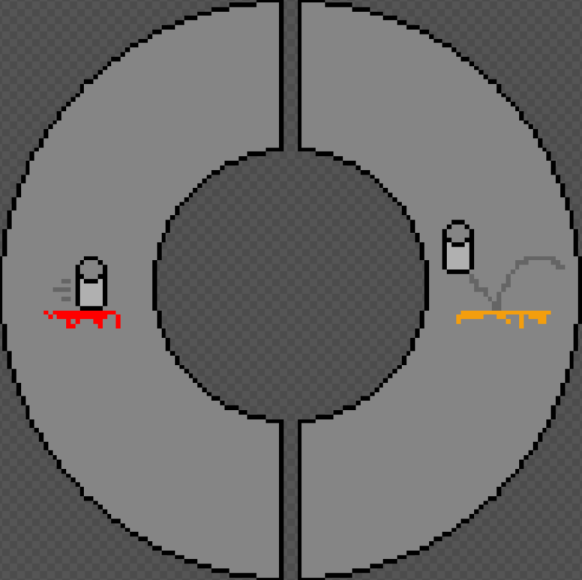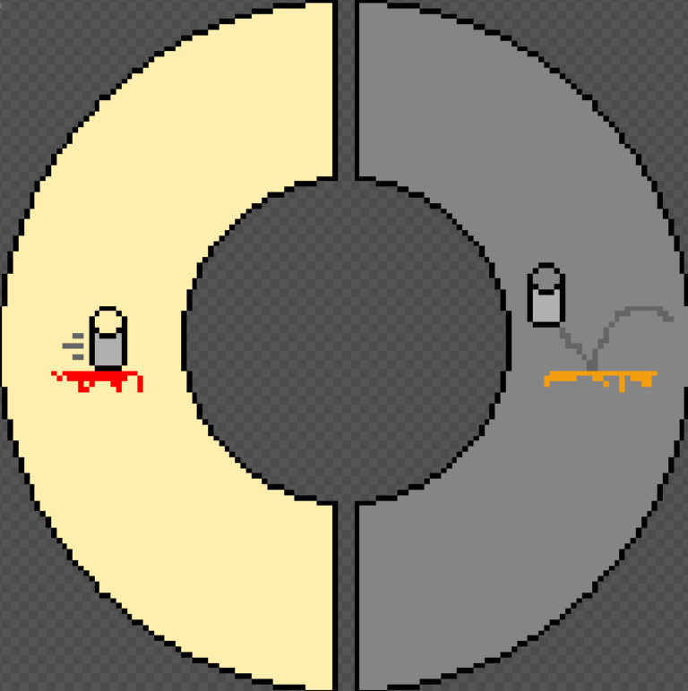

04/24/26 Archive
Block 2 to 3 (What I Did): (UPDATED: 04/24/2026 & ARCHIVED)
- General Notes:
  - The check-in went well. Everything was good. We also did tech articles.
    - I didn’t have a crazy amount of time because of this.
  - I have absolutely no clue where anything relating to the “Fire Spitter” is.
    - I need you guys to illustrate where you have been doing things (like the “Fire Spitter” I mentioned above).
    - I only see five scripts and no “Fire Spitter” prefab.
    - I want to work on coding, but I literally have no clue where to go.
      - I want to figure out where to go so I can work on Monday on some code stuff. We all need to contribute to code and I have only done a little bit of code.
  - It took me a bit to figure out what to do.
  - I mainly worked on level creation a little and a little bit of sprite work.
  - I wasn’t hugely productive today. I am a bit sick today.
- Piskel:
  - I got started on making some animations for “Egress.”
    - This was very small and I didn’t do too much with it today if anything.
    - This is a huge task and I don’t know how I will get this done.
    - I sent it to you guys right now if you guys want to help me with it. We can always base the animations off of John Egress.
      - You can use a color picker from the image to figure out what color is what on the sprite.
      - Regardless, here are some colors:
        - Blue Hair: #599aff
        - Under Shirt: #bfa47e
        - Overalls: #7f6530
        - Dark Brown Pouch/ Pads: #59451b
        - Red, Orange, and Green Paint Splatters: The same ones I gave you guys yesterday.
- Unity Engine:
  - I mainly worked on the final area in “Level 1.”
    - Everything is laid out now. I just need the “Fire Spitter” up and running.
- Notes for 04/27/26:
  - I want to get started on a coding task. I would like to know where to start (on Monday). The “Fire Spitter” and “Teleporter” are two things I would like to be able to get started on/ finish (if needed). I just need to know where to go with these things. Of course, if I get time or if the “Fire Spitter” is already done, I can continue with level creation and spritework. I just would like a big coding task that I can understand/ know how to get to since I am not great with understanding everything going on.
- Response to/ for Block 3:
  - I will work on the “Teleporter” and try and get it functioning on Monday. Keep doing what you are doing. I will probably just look at tutorials and stuff for that and add it in the “Sandbox” branch. By the way, you can edit any of my sprites if you want. If I get additional time or feel like it, I will work on some sprite stuff too. Thank you for everything. I will continue level creation when the “Fire Spitter” is done. Thank you a lot for everything.
Block 3 to 2:
- The Fire Spitter has been worked on in the “sandbox” branch, and there’s no prefab because it’s NOT DONE YET
  - Oh also maddie here just wanted to say that you can always just check all the branches by clicking the “branches” button on github and there you can see how recent it was worked on
- I checked the stuff you sent
  - I do think that there should be a more like water gun esque tool
    - Paintball guns in real life are usually relatively slower and fire pretty straight which would be good for like a weapon to paint stuff before you get to where you are going
  - I was personally thinking something similar to a splattershot so I will try making a sprite for it soon™ but we will be using your sprites still dw

04/27/26 Archive
Block 2 to 3 (What I Did): (UPDATED: 04/27/2026 & Archived)
- General Notes:
  - A progress report is due on Friday night. I will probably start working on it on Thursday.
  - Tech articles were a bit longer today.
  - I just tried to start some progress on the “Teleporter” prop.
    - I tried my best. Tell me if there are any issues.
- Unity Engine:
  - I just switched my branch, worked a little on the “Teleporter” prop, and then committed.
    - I was slow because this is new to me. I still want to do it, though.
    - I didn’t work on anything else today.
- Notes for 04/28/26:
  - I plan on continuing from where I was working in the “Sandbox” branch with the “Teleporter” prop. Tell me if I did anything wrong or if there are any issues. I will get back to work tomorrow and tell you if I need anything. I am good for now. Keep doing what you are doing.
- Response to/ for Block 3:
  - Cool, thank you for that stuff. I really appreciate it. I will keep doing what I have been doing (as stated in the bullet(s) above this) and I will keep you up to date. It seems like you guys know what to do. Just keep me informed if you need anything.
Block 3 to 2:
- I legit got nothing done as I stared at the code not work 100 times - maddie
- the fire spitter now kills on activation, plus some animation updates (those are still wip)

04/28/26 Archive
Block 2 to 3 (What I Did): (UPDATED: 04/28/2026)
- General Notes:
  - I continued my work on the “Teleporter” prefab in the “Sandbox” branch.
- Unity Engine:
  - I preserved a “backup recovery” or whatever it prompted me as I was loading Unity Engine.
    - I don’t really know why it prompted me.
  - I just worked on animations for the “Teleporter” prefab(s) today.
    - I essentially did nothing else today. I just focused on the “Teleporter” prefab today.
  - Everything should have been saved properly.
- Notes for 04/28/26:
  - I plan on continuing working on the “Teleporter” prefab more tomorrow. I should be working mainly on functionality then. Hopefully I can have it done soon. I think the animations are good. I think I did all of that stuff for the “Teleporter” prefab now. Anyway, just keep doing what you are doing. I will tell you if I need anything. I should be good with everything for now. Tell me if you need anything. I am still hard at work on the “Teleporter” prefab right now.
- Response to/ for Block 3:
  - Thank you for everything again. I will keep doing everything like I said in the bullet above. For the “Fire Spitter,” make sure you add it to my “Level 1” branch when you guys are done (but I assume you will do that soon anyway regardless). Besides that, everything seems good for now. I will keep you guys updated if I need anything. I think I am good. Otherwise, just keep me updated if you need anything too. Anyway, thank you for everything so far.
Block 3 to 2:
- I am gonna be working on paint switch but like a 75% chance that nothing works again (seriously I need something to commit and push pleassseeee unity I need this)
- Fire Spitter now works (is now a prefab on sandbox branch)
- Had no time to commit paint switch that works

04/29/26 Archive
Block 2 to 3 (What I Did): (UPDATED: 04/29/2026 & ARCHIVED)
- General Notes:
  - I worked mainly on the “Teleporter” prefab’s script and hooking it up.
  - Liam, I have two comments about the “Fire Spitter”:
    - Can you resize it to perfectly match the current tiles? I want to make sure it at least lines up well and looks good next to other regular tiles as it is more of a hybrid between a tile and a trap (but will be placed like a trap).
    - The image quality is noticeably different, can you do something about that? It looks really weird having one really high quality tile type next to lower quality ones.
- Unity Engine Notes:
  - I completed the script, saved, and linked them.
    - Currently, it does not work.
    - I didn’t have time to check anything at the end of the block, I just saved, committed, and logged off.
- Notes for 04/30/26:
  - I will probably just try and make any fixes I need tomorrow if you guys can't find any glaring issues or anything. By the slim chance you guys fix the whole teleporter, I will probably just look into making more scenes for future levels in any way I can. I don't really want to do any sprite work tomorrow. Other than that, I think I am good for now and I will likely just stick to this plan. I also might start working on the “Third Progress Report" assignment too.
- Response to/ for Block 3:
  - Thanks for the help with stuff. I figured the code was weird anyway. I just tried my best today. Anyway, I will look into that tomorrow and fix any issues with anything if they arise. In the meantime, I will probably start working on setting up the shells of more levels. Just make sure you merge if it is good by the end of my block or your guy's block so I can get to work levels with the new prefabs now. Just tell me if you need anything from me and I will also get back to you about everything on this document by the end of my block tomorrow. I would like to do more coding soon too so I might look into that tomorrow as well. Anyway, thank you guys for everything so far. I really appreciate it.

Block 3 to 2:
- *clang clang clang* RAAAAAAAA
- fixed the fire spitter quality :D
- added the finish flag sprite into main, just tell me if you need it merged into another branch
- try the teleporter now, ran out of time to test code (your old code is commented out)
  - teleporter colliders are set to triggers for that ontriggerenter2d
- ajjjajajaja

04/30/26 Archive
Block 2 to 3 (What I Did): (UPDATED: 04/30/2026 & ARCHIVED)
- General Notes:
  - Bixler was not here today so I got started immediately today.
  - I checked the “Teleporter” prefab(s) to see if they worked.
    - I tried to make fixes to it accordingly.
  - I noticed my VM felt different. I noticed the time in the bottom right corner changed back from EST to PST.
    - No idea if anything else changed, but it is probably fine.
  - I created a copy of a progress report and shared it for the “3rd Progress Report” assignment.
    - I adjusted things and did formatting as needed so we are ready to do the document tomorrow.
  - Just a side note, I don’t know if Dr. Bixler explicitly stated it, but the “3rd Progress Report” covers everything after Midterms, right? I thought he said this.
  - I had a little bit of time left over at the end (I misjudged how long things would take) so I helped Geddes with his project a little.
- Unity Engine Notes:
  - I checked the “Teleporter.”
    - At the very least, it functions.
    - It’s good that you spawn above the teleporter, but the issue is that the teleporters also lose collision upon teleporting to that location. After jumping, you teleport like normal (as the collision then returns briefly).
    - I would, personally, like for the teleporter to only function when you are standing on top of it too, not slamming to the side of it.
    - My animations (that make the teleporters flicker when used) don’t work either. They are done, but I don’t know/ didn’t have the time to fix them.
    - I don’t know if this is an issue or if you plan on doing this, but I would recommend making the “Teleporter” prefab the combined yellow and blue teleporters together that you can move around at will. That way, whenever you add another prefab to a level, it includes a link rather than just one or just the other.
  - I detailed my fixes for the “Teleporter” prefab(s) and progress with them below:
    - Collision Issue:
      - I first made a second, overlapped collider to both teleporters as I was recommended to online. One of them has “Is Trigger” turned on, the other one that is new does not.
        - It fixed the issue, but you can’t jump after landing on the destination teleporter.
          - I didn’t fix the jumping issue today.
    - Side Teleporting Issue:
      - I indirectly resolved this issue by trying to fix the lack of jumping capability after teleporting.
        - I specifically shrunk the “Is Trigger” 2D Box Collider slightly.
- Notes for 04/30/26:
  - I plan on working mainly on the “3rd Progress Report” assignment tomorrow. If I get time, I can look into the progress you guys made today and possibly make some level edits (probably for “Level 1”) if I finish early and the branches are merged so I can use the new things. If the branches aren’t merged, then I will probably just go and work on either sprites (if I find anything to do) or more level shells for future levels (if I feel like it). Besides that, just keep doing what you are doing. Please try and fix the issues/ merge the branch as soon as possible today. Tomorrow, just make sure to work on the “3rd Progress Report”, updating the Github (if needed), and updating the Trello (if needed). This should detail everything for tomorrow. I will keep you guys updated on the questions I answer for the “3rd Progress Report” assignment. Thank you for everything and keep at it.
- Response to/ for Block 3:
  - I still plan on doing the “3rd Progress Report” tomorrow and I will keep you updated on what I do and what I need you to do. Make sure you check the Github and Trello and update them accordingly (as Dr. Bixler wants everything done). If I get time, I will look into trying to fix and rework the existing animations for the “Teleporter” prefab(s). Since you aren't done, I won't do anything level creation related. If I get done with that as well, I will just look into sprite stuff. Anyway, that is probably my plan for tomorrow. I will let you guys know how everything goes. Just keep me updated about your guy's block and keep doing what you are doing. Thank you for everything so far.

Block 3 to 2:
- I made it so that the teleporters will reverse your y momentum (think about portal and how jumping through one keeps your momentum, just reversed)
  - just tell me if you don’t like this
  - you can now jump on the teleporters btw
- player movement updated for what i want to do with teleporters
- Paint Switch has been pushed to painting branch so painting can add the code to actually switch the paint when done
  - Paint Switch remains active bc I need to do the 3 way wheel now…

05/01/26 Archive
Block 2 to 3 (What I Did): (UPDATED: 05/01/2026 & ARCHIVED)
- General Notes:
  - I just worked on the “3rd Progress Report” assignment.
  - Make sure you update the Github (if needed). It’s not listed on the “3rd Progress Report,” but it is still important.
  - Just review the full bullet point(s) below to get all of the information you need about the “3rd Progress Report.” It shouldn’t be too bad.
  - Also, I transferred the ownership of the “3rd Progress Report” document to you Liam. Just make sure you submit!
- “3rd Progress Report” Assignment Notes:
  - I guess I am just going to work under the assumption that he wants everything we did after Midterms (labeled the fourth sprint).
  - The assignment should be shared already.
  - I highlighted everything that needs to be done still. It includes the following:
    - “Difficulties Encountered this Progress Period” - I added some stuff I knew about, but more information regarding what I added and possible other issues is up to you guys.
    - “Updated Trello Board and Discussion”
    - “Tasks to be Worked on Next Progress Period”
    - “Summary of Progress of this Period”
    - “Detailed Progress Period, separated by Team Member” - I added my section, but you guys need to add yours.
    - “Additional Information” - Only add stuff if you need to.
  - I completed the following questions; Additionally, I set up the whole document already and had it shared:
    - “Summary of Project”
    - “Difficulties Encountered this Progress Period” - I added what I knew about any difficulties.
    - “Detailed Progress Period, separated by Team Member” - I added my section, but you guys need to add yours.
  - Make sure to un-highlight stuff and submit when you guys are done.
- Notes for 05/04/26:
  - I will try and fix the animation issues and anything as soon as possible on 05/04/26. I want to be able to get back to work on level creation as soon as possible. Liam, just make sure to finish everything you can do and I will finish everything I can do regarding what needs to be done on the “Sandbox” branch so we can merge and I can get to work on level creation. If anyone knows what to do already and can fix that sooner than great, but don’t overwork yourself past the time you have in class. My main focus on 05/04/26 will be fixing any issues I need regarding the “Teleporter” prefab so we can get everything merged and I can continue the level creation on 05/04/26. If I get time, I will work on what I planned to do if I had extra time today on 05/04/26 (i.e. any sprites needed or any future level shell set-up and other things relating to that). If everything is done by 05/04/26 (not very likely), then I will get right back to work on trying to finish the shell of Level 1. Just keep in mind as a note for the future, we will need to have a mechanic/system for the player to transition between levels after level completion. Those screens and things are of course not done and will probably be done a bit later down the line. At least for now, I will likely add the “Finish Flag” to the end of Level 1 to indicate when the player has completed the level. This is all just level creation stuff I will work on once the “Sandbox” branch stuff is added to where I can work on adding that stuff to Level 1. Anyway, thank you guys a lot for everything and keep doing what you are doing. I will keep you updated on everything. Keep me updated on everything too (like whether/ when the “Third Progress Report” assignment is done). Thank you.
- Response to/ for Block 3:
  - The progress report looks good. Feel free to submit it whenever you like. Just tell me when you do so I can mark mine as done. Anyway, I am probably just going to stick to the plan in my bullet point above. Thank you guys for everything. Just keep doing what you are doing. I will tell you if I need anything. Thank you.

Block 3 to 2:
- I believe the progress report is done, feel free to check it out -Liam

05/04/26 Archive
Block 2 to 3 (What I Did): (UPDATED: 05/04/2026 & ARCHIVED)
- General Notes:
  - I worked on trying to make the animations cycle on the “Teleporter” prefab(s).
  - Just tech articles like normal.
  - Progress reports will be reviewed by Wednesday.
  - The VM was VERY slow today.
- Unity Engine Notes:
  - Hopefully it fetched properly because the VM was running VERY slow today.
  - Things to be Fixed/ Changed:
    - The “Teleporter” prefab is fine, but I think it could be a little bit better.
      - I like the momentum increase, but I honestly think this could lead to too many exploits and it also doesn’t allow you to stand on the teleporter itself. Maybe you could make the height carry over from high jumps, but when you land, it doesn’t take you into an infinite loop and it allows you to stand on the target location after falling. I like the momentum carrying, but I don’t like the infinite loop. If you have to sacrifice anything and can’t fix it in the way I described, keep the ability to stand on the target teleporter’s location.
        - I attempted to fix this and I did sacrifice the inverted momentum. You can try to re-add it, but I would prioritize keeping it similar to the way it is now (which is allowing you to jump upon landing after teleporting. I would also like to add that it appears the jumping after teleporting thing only works sometimes (I think in a short interval after teleporting; After that, it won’t let you jump on the teleporter at all). You might want to look into this, Liam.
      - I don’t know why, but the issue of teleporting when touching the sides of the teleporter is back. I don’t think it is a huge issue, just a minor inconvenience. Don’t go crazy over it if you can’t fix it.
        - I think I fixed this issue.
  - The animations should cycle now! Feel free to merge when you fix what I described above.
  - Liam, just take a look at the stuff I did in this block in Unity Engine for more information.
  - Another thing to note. I think the tiles in the “Sandbox” might be bigger than the ones in Level 1. Either that or John Egress is smaller. Anyway, just make sure things are scaled properly to be used in Level 1 and future levels before merging.
- Notes for 05/04/26:
  - I think I am going to try and just make the scenes for more levels tomorrow. I can also give you guys a plan (that can be edited) for how I think things could be laid out in terms of levels. On top of this, if I get time to work in the scenes themselves, I might start working on/ in a “Level Hub” to be used to go to each level. We could maybe use similar logic to the teleporters, but use a locked sprite (dimmest yellow/ blue sprite) for when you don’t have a level unlocked and then just use the teleporters themselves to go between each level in the hub. Of course if we reused the teleporter sprites too, we would have to make a copy of them. This could also save us some time too. This is just food for thought. Just make sure you get back to me on this. If I have time, I will look into other sprites too and might work on them depending on how I feel (but probably not). Maddie, you could also look into the sprites I already sent you for the background and you could work on them as well. I am honestly not too sure about them. I think I need someone else to help with that and look into that. Anyway, that is essentially it. Just keep me updated on everything and please get back to me on this stuff when you can. I will make sure I keep you guys updated too. Thank you for everything.
- Response to/ for Block 3:
  - I will probably just swap all of the sprite colors (besides the character sprite, you can do that Maddie) first. After that I will work on what I said above regarding making the scenes for levels, planning stuff out, and working on a level hub. If everything gets done, which it will very likely not, I will work on sprites more. Just keep doing what you are doing and keep in mind what we need to get done. Whenever the branches are merged so I can add stuff to Level 1 so I can essentially finish the shell of it I will. I will plan that out later once it is done. Anyway, just keep doing what you are doing and I will stick to this plan tomorrow. Just keep me updated on everything and I will keep you updated too. I will continue to keep planning for each day too. Anyway, thank you guys for the work you've been doing.

Block 3 to 2:
- yuri
- fixed a teleporter bug where you can immediately jump (in midair) after teleporting
  - we have 2 teleporter options:
    - the one we have now
    - using overlap boxes (more intensive, but would probably fix being able to teleport touching the sides)
  - tried to change the animations but it turned out i did literally nothing new lmao (ill make my changes later)

05/05/26 Archive
Block 2 to 3 (What I Did): (UPDATED: 05/05/2026 & ARCHIVED)
- General Notes:
  - He returned our “3rd Progress Report” so I took a look at that (and you should too). Here are my responses to everything:
    - He said it needs a lot more detail overall so we should make sure we add videos where needed, pictures of code, etc.
    - I don’t know if he wants it resubmitted or not. Does he? - Please Respond
    - He said it looks like I haven’t pushed a commit in two months. Do you know what that is about, Liam? I thought it should have been working. If you know why, can you tell him? - Please Respond
    - I mentioned my archived (this document) and he said to store it somewhere digitally? Isn’t that what this is? - Please Respond
    - He wants you to add more specifics and pictures, Maddie. - Please Respond
    - Liam, he also wants screenshots/ videos from the stuff we both did too. - Please Respond
    - Liam, he wants details on some errors I believe you mentioned too. - Please Respond
    - Trello was good so at least that is something, lol.
    - He said it would be helpful if we all set a goal for each progress period to prevent progress slippage. I am not sure what to do about that since I have been kind of just working wherever I am needed most. - Please Respond
    - A LOT OF STUFF HERE. It seems like he wants it in the next day or so for credit I believe. - PLEASE RESPOND
  - I first worked a tiny bit on editing the “3rd Progress Report.” I sent a copy to you guys since I couldn’t edit it. You guys should work on it too if he wants us to resubmit. I am not sure about how to do the video stuff (like what he mentioned with the teleporter) so we need clarification on if we need to do it because I don’t know how currently.
    - I edited what I could relate to my stuff. The only thing I couldn’t do relating to me was the videos (that I don’t know how to do for the teleporter and don’t know if I need to add it or if you could add it, Liam), the GitHub comment at the beginning, and the comment about the “digital archive” which I am not even sure about since I thought this was digital (maybe he didn’t know). - Please Respond (& clarify what I need to do to fix this stuff or if I need to do anything at all).
    - I added a couple photos and what I plan on doing in the “Sprint 5” since that is everything I could do. If you need to copy and paste this stuff onto the original document, you can, since I don’t currently have edit privileges. All I did was make a copy and share it with you guys. Liam is the owner, too.
  - The only other thing I was able to do was edit the sprites since I was so focused on the comments on the “3rd Progress Report.” I will get to the things I mentioned yesterday tomorrow because of this.
    - I listed what I did below (which includes all of the sprites I made with colors I believe), Maddie. Just tell me what you think or if I need to do more. I resent them to you guys accordingly. - Please Respond
  - Liam, please finish the merge so I can continue my work in level creation too. I really need it done right now. - Please Respond
- Unity Engine Notes:
  - N/A
- Sprite Work Notes:
  - I changed the colors for the following and sent them accordingly; You originally just wanted me to change the green and orange so I did just that:
    - “Paintball(s)”
    - “Egress Character” - I only send the Piskel file to be continued to be worked on!
    - “Paintgun(s)”
    - “Left, Right, and Middle Droop”
    - “Pre-Painted Tiles” - I also edited the green icon too!
    - “Color Wheel” - I also edited the green icon too!
- Notes for 05/06/26:
  - Copy & Pasted & Slightly Edited From 05/04/26: I think I am going to try and just make the scenes for more levels tomorrow. I can also give you guys a plan (that can be edited) for how I think things could be laid out in terms of levels. On top of this, if I get time to work in the scenes themselves, I might start working on/ in a “Level Hub” to be used to go to each level. We could maybe use similar logic to the teleporters, but use a locked sprite (dimmest yellow/ blue sprite) for when you don’t have a level unlocked and then just use the teleporters themselves to go between each level in the hub. Of course if we reused the teleporter sprites too, we would have to make a copy of them. This could also save us some time too. This is just food for thought that I might look into or work on if I get the time to. If I have time, I will look into other sprites too and might work on them depending on how I feel (but probably not). Maddie, you could also look into the sprites I already sent you for the background and you could work on them as well. I am honestly not too sure about them. I think I need someone else to help with that and look into that. Liam, please finish the merge so I can continue my work in level creation too. I will get to that soon and maybe last if I get time tomorrow. I really need it done right now. I can also work on more color changing sprite stuff if you really need it, Maddie. Anyway, that is essentially it. Just keep me updated on everything and please get back to me on this stuff when you can. I will make sure I keep you guys updated too. Thank you for everything.
- Response to/ for Block 3:
  - Thank you a lot for talking to him about this stuff. Also, thank you for merging, Liam. I think I will just still stick to my plan I have for tomorrow above with the only change being that I will change the symbol on the pre-painted green block. I will tell you guys when I get to working on Level 1 directly. Right now, I am going to stick to that plan of working on the level hub, planning out levels, and making the scenes. If I get time to, I will start the finishing touches on Level 1. The last priority right now in terms of what I will do tomorrow is sprite work. I will get to sprite work at some point soon and will try to work on it in the background. Other than that, I will just stick to the plan I already had for tomorrow above. I will plan what to do next tomorrow based on what I finish and what I don't get to that I want to get done soon. Liam, just make sure the “3rd Progress Report” gets recompleted and resubmitted soon. Just tell me when you do that. Other than that, thank you guys for everything. Just keep me updated and I will keep you updated too if I need anything. Thank you a lot.

Block 3 to 2:
- answers
  - 1. Yeah he did for other people who had to work again on progress reports so this prob isn’t different…
  - 2. He was likely checking the main branch. Your last commit to the main branch was March 11 (2 months ago). All your commits have been coming through, don’t worry. (Maddie here I went up and talked to him he just wants to make sure we don’t forget about main)
  - 3. resolved. this document is exactly that (Maddie here I went up and told him and he thought we were just handing back and forth scrap paper lol)
  - 4. Idk why I need to respond to this… yeah I saw the comment and it is resolved :p
  - 5. will work on videos at home, screen recording will kill the vm due to how slow the vm and host is.
  - 6. will elaborate on the new progress doc
  - 7. the goal is to complete painting, feel free to join me in working on it (we can split up the tasks)
  - 8. looks like it, no grade posted on classroom yet, although it was the same for the other progress reports
  - 9. looks fine to me
  - 10. I mean one thing is that you don’t need to work on any more paint wheel things that is done rn just one thing about the pre-painted green sprite maybe make it look a little bit less like a goo blob
  - 11. merged into main👍, merged into level 1

05/06/26 Archive
Block 2 to 3 (What I Did): (UPDATED: 05/06/2026)
- General Notes:
  - We only have 17 full days left so we got to speed up and get to work on level creation soon with some additional sprite work there too. Once the paint is done, that will likely be all of the traps/ mechanics unless you guys want to add something else.
  - The first thing I did was make a new symbol for the pre-painted green block.
  - The next thing I did was try and get a level hub up and running through the “First Level Tests” branch as I figured it made sense (unless you guys want to move it somewhere else).
  - I also planned some ideas about future levels below!
    - This is not yet finished and I will copy and paste it onto tomorrow's notes and finish it then after I do what I want to do tomorrow.
  - Maddie, I don’t see the “finish flag” prop here. Did you not add it to this branch (“First Level Tests”)? Just curious. It doesn’t matter today but I would like it there soon, preferably, if you have already finished it. - Please Respond
- Unity Engine Notes:
  - I switched to the “First Level Tests” branch and made a new scene called “LevelHub” in the “Levels” folder.
    - I didn’t start drawing it out yet because of an issue:
      - I don’t know how to get a new scene with everything set-up like how it is in “Level 1.” I need “John Egress”, the camera to function, and my “tilemap”/ “tile palette.” Liam, can you help me with this? Right now, the “LevelHub” scene is just empty. - Please Respond (& explain how I could do this for other levels too if you can)
- Piskel Notes:
  - I made a new version of the pre-painted green block with a new symbol.
    - I sent it to you guys accordingly.
    - Maddie, tell me what you think. I can’t really think of any other ideas so I want to know if you like it. - Please Respond
- Plans/ Ideas:
  - In terms of how many levels we can feasibly do, how many we want to, and how many we need to do I would say that we should do the following; To be fair, though, this is still subject to change and you guys can add comments; This also isn’t too elaborate right now: - This is a work in progress I will copy and paste onto tomorrow’s notes and likely finish; Don’t Respond
    - “Level Hub” - Just a room, possibly wider screen and with a fixed camera depending on if we want to do that, that has little slots for each level with an off or on teleporter (depending on if you beat the previous level). This new “teleporter” would just function as a way to transition between levels. We can also add more decorations and find some sort of way to label each level in the “Level Hub” if needed.
    - “Level 1” - Primarily an introduction to the movement mechanics of our game that showcases all of our traps too. It doesn’t have every mechanic, like the teleporters.
- Notes for 05/06/26:
  - I want to primarily work on finishing “Level 1” tomorrow purely in terms of mechanics and blocks (a.k.a the shell, not decorations yet (we will have to solve that later; Probably, we can get to that when we all move to level creation). I will keep you guys updated on that. After that, I will continue more planning/ level planning based on what I already wrote down today in my “Plan/ Ideas” notes. I will get back to you on that as well. After that, my next priority will be to make the layout for the level hub (if I can as I need help getting it up and running), making scenes themselves for future levels, and starting to set them up too if I can. This task will likely get back to being on Friday. Lastly, sprite work is always there if I have extra time or if I need something to do. Anyway, just keep me updated if you guys need anything. I could always help with the code for the paint mechanic, but I don’t want to slow things down if you have already made a bunch of stuff and don’t want to go through the hassle of explaining everything to me Liam. I probably have done enough coding stuff for now (if you think so, Liam) [respond if you want to]. Anyway, that is likely what I will be prioritizing tomorrow. Just keep me updated and I will keep you guys updated too. Thank you!
- Response to/ for Block 3:
  - Just scrap the level hub, it's ok. You guys can figure out the green icon for the pre-painted blocks. I have no other ideas. Tomorrow, I will continue doing Level 1 work. If I have time, I will move onto planning more scenes/ levels. After that, I could start getting to work on making new scenes for future levels (if I can). Other than that, sprite work is still going to be last for now. I will try to get to things in this order and keep you updated on what I get done. Again, I can always help with the paint mechanic if you want or if I get time to whenever. I will keep you guys updated on everything else going forward past tomorrow too. Make sure to keep me updated on anything too. Thank you a lot for everything.

Block 3 to 2:
- “it looks like a bomb” - ed, commenting on the new green pre painted tile
- “Radioactivity?” - Emma commenting on the new green pre painted tile
- can we get level 1 finished??
- also, a level hub is included in a stretch goal (“Level select to Sandbox”)
  - level 1 still needs finishing btw, fire spitter and teleporter is merged in there now
  - we need to get level 1 into main, level hub is not viable right now
- there is a finish flag, but it’s only a sprite
- I like yuri :3
- i ended up helping maddie with paint switching/helping her study for calc
  - besides, my vm had the greatest idea to crash multiple times so yeah
- paint switching is merged into painting

05/07/26 Archive
Block 2 to 3 (What I Did): (UPDATED: 05/07/2026 & ARCHIVED)
- General Notes:
  - I primarily worked on finishing “Level 1.”
- Unity Engine Notes:
  - I focused on adding things for “Level 1” for a bit to make it interesting, but not too hard.
    - All I did was try and figure out how to ‘tamely’ add “Fire Spitter(s)” to make that section at the end interesting.
      - I, personally, don’t think it is too hard (and Ryan beat it on his first try). - Please Respond
    - I did not end up adding the “Finish Flag” yet. I don’t know what I am supposed to do with just a sheet of animations. I can make it a prefab if you want? - Please Respond
    - I also did not end up adding any decorations/ background tiles (obviously). My idea for background tiles is just slightly darker (or less saturated) versions of the main tiles we have and just make them on a different layer (not interactable with the player character). That is just me. In terms of decorations/ editing sprites (like editing the checkpoint) that idea is entirely up to you guys (if you want to do that at all). We can get to this whenever. I am just trying to plan ahead. - Please Respond
    - All of the bullets above essentially showcase everything done or that needs to be done for “Level 1” to be done. I would say it is at a “soft” release with its lack of decorations, background tiles, and finish flag, but it is “technically” done in terms of the main mechanics themselves.
- Plans/ Ideas:
  - In terms of how many levels we can feasibly do (which I personally think is roughly five (including what I have already done)), how many we want to, and how many we need to do I would say that we should do the following; To be fair, though, this is still subject to change and you guys can add comments; This also isn’t too elaborate right now: - Please Respond; At least for me, I feel like this is a good format to follow when we all start making levels. Everything I list here includes every main mechanic. Things like secret(s), coins, and a buzzsaw launcher (which I previously had planned) would probably just be scrapped unless you guys want to re-add them. Feel free to give you opinions on this. I feel like this is just a good layout to help keep us on track when we shift towards level creation. We DON’T have to follow it to a T.
    - “Level Hub” - [CANCELLED] - We will likely have a level selection menu with buttons and art instead of this because it isn’t a priority and we don’t have the reasonable time to work on it.
    - “Level 1” - Primarily an introduction to the movement mechanics of our game that showcases all of our traps too. It doesn’t have every mechanic, like the teleporters.
    - “Level 2” - Primarily focused on our first paint color, which will likely be red (in my opinion), and how it can be used in relation to traps and other mechanics. This level would probably still lack the teleporter mechanic as it isn’t really needed for something like this. Since it is focused on the red color paint, this level would be focused on speed and kind of formatted like a crazy platforming speedrun (unless we want to format it more like “Level 1”).
    - “Level 3” - Primarily focused on our second paint color, which will likely be orange (in my opinion), and how it can be used in relation to traps and other mechanics. This level would likely have the teleporter since I personally think it would work well and be interesting to constantly be bouncing around and literally hopping from section to section. Since it is focused on the orange color paint, this level would be focused on bouncing, it would likely be more vertical rather than horizontal in layout (unless we want to format it more like “Level 1”).
    - “Level 4” - Primarily focused on our third (and final) paint color, which will likely be green (in my opinion), and how it can be used in relation to traps and other mechanics. This level would likely have the teleporter (but not be a focus) since I personally think it kind of falls similar to where the red paint was in terms of mechanical integration (and it doesn’t really ‘fit’ the same way it does for the orange paint, although since the mechanic was already introduced, it still could be here). Since it is focused on the green paint color, it would likely be more focused on precise platforming, similar to “Level 1” but essentially just more interesting since there is an additional mechanic added to the platforming that is more precise and less slippery than the other paints.
    - “Level 5” - This would likely be our final level. This level would showcase, probably in multiple sections, how each paint works together and how they can be used in a really interesting format. Since every mechanic would be introduced at this point, anything is at play. Mechanics, like the paint tools, would also already have been fully integrated (and be more supplementary (even throughout all previous levels). This level would probably end with a grand finale of some sort I don’t really know yet though.
- Notes for 05/08/26:
  - I am not too sure what to start for tomorrow. I could shift gears into trying to make the layouts for more levels (if you want), but I don’t really have all of the tools to do so yet (obviously) so what I would do would just be simple, base-level, stuff. If you guys want, I could also help with the paint mechanic or adjacent things as long as it doesn’t require me to try and interpret all of the code you are doing, Liam, or interfere with what you are trying to do. I am mainly just trying to be helpful in ways that are not just sprite work so feel free to give me suggestions because I am not too sure right now. I can do sprite work, but I would prefer not or at least not the whole block tomorrow. Anyway, just get back to me on this so I can solidify what I am doing. I would probably just try doing anything I listed above with no clear direction. Thank you guys for everything. Just keep me updated on this and I will keep you guys updated on everything too on my end. - Please Respond; I need some direction or confirmation on what I am doing. Just suggest things to me or confirm that the things I listed above make sense or are important/ should be worked on. I am really just not too sure on this so just add some input please. Thank you.
- Response to/ for Block 3:
  - Cool, I will probably just get to work on a functioning finish flag prefab that also teleports you to another scene or teleports you back to the start of the level (maybe, for now if the former isn't possible/ simple enough). I will make sure to add animations if they don't function already either and work in the Sandbox or new UI branch, but probably the new UI branch. I doubt I will finish or get time but some other things I could work on in the following order are the basic scene structures for future levels or sprite work if I feel like it. Again, I can always work on paint related stuff if you need me to. Anyways I will probably stick to my plan above if that's fine. I will make sure to keep you guys updated on how everything goes tomorrow and in the future. Make sure to keep me updated on stuff too. Thank you guys for everything!

Block 3 to 2:
- level 1 is pretty good
- the finish flag should show some UI that says smth like “Level Complete!” and then a clickable button to move to the next level (which will only restart the level for now, as there’s no level 2 yet or it could also just go to sandbox for testing)
  - the game should also stop inputs and stuff (Time.timeScale = 0f;)
  - Work on the finish flag in the new UI branch please :3
- those sound good for background tiles
- Fixed Green block it is much more clear now please take a look
- started working on the red pre painted tile and its effects

05/08/26 Archive
Block 2 to 3 (What I Did): (UPDATED: 05/08/2026 & ARCHIVED)
- General Notes:
  - The tech articles were a bit longer today.
  - I worked specifically on the “Finish Flag” in the “Sandbox” branch because it was just easier than the UI focused branch.
  - Just one thing, Maddie, I didn’t work in the UI branch because I thought it broke when I tried to mess with scenes. I now know nothing actually happened. I just ended up working in the “Sandbox” branch because of this.
- Unity Engine Notes:
  - I primarily focused on adding the animation today (which took a little bit longer than anticipated). I should have everything set-up in that department right now. Not much else to comment on today.
    - All I need to do is make the script on Monday (which hopefully shouldn’t take too long) and test it (but I have no idea if it will end up working or not so hopefully it will).
      - From the looks of it, adding the scene transition seems even easier than adding animations.
      - Hopefully this isn’t too bad. I have everything set up in the “Level 1” scene in the “Sandbox” branch and I will probably have it transition to the “Sandbox” scene. This is the plan (at least for now) that I have for Monday.
- Notes for 05/11/26:
  - I primarily plan on finishing and testing out the “Finish Flag” prefab on Monday after I create and apply the script. I will tell you guys how it goes and if anything needs to be fixed. Hopefully it goes well and I can continue on to other small things. I likely won’t have extra time on Monday (if there are any minor issues or anything), but in case I do, the plan is to just do the same stuff I would have done today if I had extra time. I doubt I will finish or get time but some other things I could work on in the following order are the basic scene structures for future levels or sprite work if I feel like it. Again, I can always work on paint mechanic stuff/ code, but I don’t know if you really want me to bother you or make the process harder to make that stuff work, Liam, so do with that what you will. Anyway, depending on what happens on Monday I will plan for Tuesday accordingly (which I am not entirely sure where I will go with yet). We will see what happens with that. Anyway, I will make sure to keep you guys updated on everything regarding the project and if I have any questions. Just make sure to keep me updated too as well. Thank you, again, for everything.
- Response to/ for Block 3:
  - I will probably check the red tile first thing Monday if I get the time to. Sounds good. Anyway, I will very likely just stick to the plan I have in the bullet above. Other than that, there isn't really much else I have to say. Just make sure to keep me updated on everything and I will too if I have any questions or if there is anything else important to say. Thank you guys for everything.

Block 3 to 2:
- red tile finished
- orange tile wip
  - check it and see if you like it

05/11/26 Archive
Block 2 to 3 (What I Did): (UPDATED: 05/11/2026 & ARCHIVED)
- General Notes:
  - We had 10 minute tech articles like normal.
  - I checked your red tile, Maddie.
    - I have no idea where it is. Please tell me… - Please Respond
  - I continued progress on the “Finish Flag” prefab (although it wasn’t completely fruitful).
- Unity Engine Notes:
  - I attempted to get the “Finish Flag” prefab up and running…and it did not work.
    - Liam, you can look into it if you want to leave any comments or anything. I plan on getting back to fixing that stuff tomorrow, so don’t do anything with that. Just tell me if there are any glaring issues (if you want to or have the time to. - Please Respond
    - Right now, all I did was add a script (although it is not currently functional after I tested it) and get the animations at least working (although the animations are not working in the right way).
    - I didn’t have time to make any edits to the “Finish Flag” today. I literally just got to test it just after finishing the script and leaving comments in the script.
- Notes for 05/12/26:
  - I plan on getting back to try and fix the rest of the “Finish Flag” tomorrow. If I can’t by then, Liam, then I might need you to help me make some edits to that stuff. I will see what I can get to tomorrow. I could always look more at the “Checkpoint Flag” prefab for more inspiration (especially for the animations) regarding the “Finish Flag” prefab. Besides this, I will likely have time to start the things I mentioned I previously could possibly get to earlier. Specifically I am referring to working on setting up scene stuff in Unity Engine and working on sprite work in Piskel. These are just some options of stuff I can do later tomorrow if I manage to fix the “Finish Flag.” Longer term, I can always help with the coding with the painting mechanic if that is still on the table or you need more help with it, Liam. Other than that, that is my plan for tomorrow. I will probably have a new plan and start working on/ continuing other things on Wednesday possibly based on what we still need to get done. Anyway, just make sure to keep me updated on everything. Thank you guys a lot for everything! - Please Respond
- Response to/ for Block 3:
  - First of all, I still am not exactly sure where the effects are for the red pre-painted tile so I will leave that be. I am sure it is good. Anyway, so my main goal is to fix/ add to the “Finish Flag” prefab in three specific ways. I need to rename the animations from whatever random names were in the animation web to be more specific, short, and descriptive. I need to fix the custom function to have the level transition activate by reviewing the fire spitter's animation clip (but specifically the part for the deactivation that is labeled or indicated by a red dot). By reviewing the fire spitter's animation clip, you can reference it for your custom function for the “Finish Flag” prefab to work properly. Lastly, I need to (possibly) add a function or something to make the level freeze briefly after it is completed. Other than that, I will stick to the same plan I have in the bullet above for after I complete the fixes to the “Finish Flag” prefab if I even do at all. That is all. Make sure to keep me updated on everything. Thank you guys a lot.

Block 3 to 2:
- Liam was talking about coding the tiles I have made no tiles besides green
  - yeah it was the red pre painted tile + its effects are done
- Finish Flag Issues:
  - the “custom function” is never run at all
  - animation loops (fixed)
  - rule 1 of having an onentertrigger2d: you need a collider2d (fixed)
  - i would suggest having actual names for the animation clips
    - “New Animation Finish Flag Real” is not that great of a name
    - also move the animation clips into the animations folder that i think you created
  - consider: freeze time when the flag is reached (but also keep the animation go after the time freeze)
- also how did you get the level1 stuff into the sandbox branch? there are a lot of broken things in the sandbox version of level1 (don’t fix them)
  - wait nvm who the hell merged sandbox into the main branch???
- Rate my Menus:
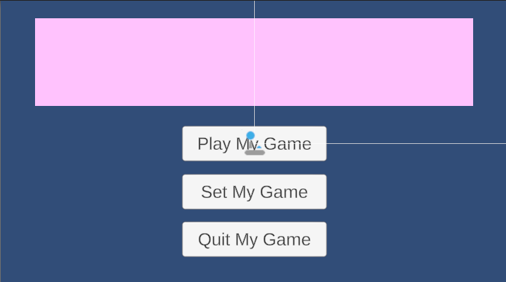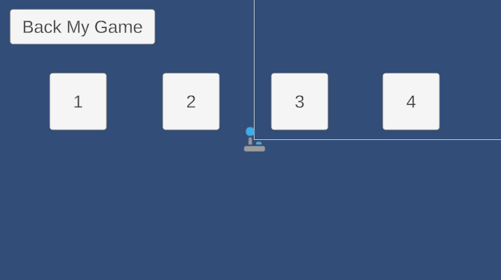

05/12/26 Archive
Block 2 to 3 (What I Did): (UPDATED: 05/12/2026 & ARCHIVED)
- General Notes:
  - I spent the entire block trying to get things to work, but nothing does.
  - I mainly attempted to fix the “Finish Flag” prop in Unity Engine, but to no avail.
- Unity Engine Notes:
  - I specifically first renamed the animations in the animator to be more coherent like you said, Liam.
  - Then, I tried to get the actual thing to work, with the custom function and all, and nothing happened. I even went into the animations tab and added the custom function as a function to happen on the final frame of the animation. Still, nothing happened.
    - I genuinely have no clue what to do about this. You can look into this if you guys want to, but I have no solutions right now and don’t know if I will be able to find one tomorrow. - Please Respond
  - I, obviously, did not get to work on the freeze frames yet for the “Finish Flag” as you transition from one level to the next. I could always do this later when at least the “Finish Flag” actually works. This is exactly why I didn’t get to this task regarding the “Finish Flag” prefab.
- Notes for 05/13/26:
  - I am not really sure what will happen regarding tomorrow since there is no way I will be able to fix anything regarding getting the “Finish Flag” actually working unless you guys have it working (so I can make the freeze frames possibly) or know how to make it work and I can just implement what you need me to. I could always add these things to my plan tomorrow depending on what you guys actually do today. Some other things I could work on are adding new scenes (essentially as husks with not too much in them since all of the mechanics are not done) or sprite work (although I don’t know what sprites I would even work on unless you guys have some suggestions). Again, I can always help with paint related tasks/ code if you need me to. Anyways, tell me if you guys want any of the things I listed done depending on what you guys do today and give me specifics if warranted (like with sprite work). If you guys want me to do something else, just let me know all of the specifics because I am not really sure what else to do right now. Anyway, just keep me updated on this and everything. Thank you guys a lot. - Please Respond
- Response to/ for Block 3:
  - I will make sure I won't press the checkmark again in the finish trigger again, my bad. I think I know what you mean. Tomorrow, I will try and look into enhancing the “Finish Flag” by adding any non-existent animation features (if they haven't been fixed already and if I can). After that, I can try and get the freeze frames before the transition from one level to the next on the “Finish Flag” prefab up and running too. When I am done with all of that stuff I will likely move back onto sprite work because I need a little break from this stuff (at least for a little bit because I suck at coding, lol). I will probably just focus on the title based on the details you provided below. Other than that, I will check out to see any other sprite related things I can do based on your comments below. I will make sure to keep you guys updated on where I am going next after that, although I am not too sure. That is all. Anyway, just keep me updated on everything and I will do the same thing too for you guys. Thank you guys for everything!

Block 3 to 2:
- You could work on sprites (Mainly the 600x120 title or some sprites for some of the buttons like levels and stuff) or a font for the settings & stuff
- finish flag will now load another level when touched (stop pressing the checkmark on the finish trigger, that will break in the final)
- continued work on orange pre painted tile
- Uhm me made it so when click menu button it go to thing it need to go to
  - Gonna start working on yuri settings next (or maybe pause?)
- Panic in static out manic don’t you find it all romantic the way things used to be

05/13/26 Archive
Block 2 to 3 (What I Did): (UPDATED: 05/13/2026 & ARCHIVED)
- General Notes:
  - 10 minute tech articles again so I had less time to work on stuff.
  - I mainly just ended up working on some additions to the “Finish Flag” prefab!
- Unity Engine Notes:
  - I added some additions to the “Finish Flag” prefab!
    - Now, there is an adjustable time delay in the inspector for the flag that allows you to make a time delay between the flag turning green and the scene loading fully.
    - Additionally, there is a slow motion effect attached to this time delay that is adjustable in the script for the “Finish Flag” prefab.
  - The “Finish Flag” prefab should be done now!
    - Tell me what you guys think of the additions I made and if you think the “Finish Flag” prefab is good now too. - Please Respond
- Notes for 05/14/26:
  - Honestly, I have a small idea of what I could work on tomorrow, that I will state right after this, but please feel free to give me any suggestions if you want me working on something else. Right now, I also think I have a good idea of what I might get to on Friday if I finish my part for the “4th Progress Report” early (and it would obviously also apply for the Monday after). I will mention that on tomorrow’s notes for the next day (a.k.a. 05/15/26). Anyway, for tomorrow, I was thinking I could do more Piskel stuff (i.e. the starting screen, menus, U.I., or anything else to work on in this regard if you guys want me to do this stuff) and make the sprites for some of the important things I listed before this. Feel free to give me any other suggestions if you want me doing something else or if you want me/ don’t want me working on any of the sprites I just listed. Anyway, after that, I was thinking I could get a head start toward the end of the block on the “4th Progress Report” just to make sure we can complete it in class (since our last progress report and the adjustments we made could make this progress report longer in scale). Anyway, that should be everything. Just keep me updated on everything and I will too. Thank you. - Please Respond
- Response to/ for Block 3:
  - I think I have said all I need to say above this. I plan on doing sprite work in Piskel and then working on the “4th Progress Report” a little bit probably at the end of the block. That is probably all (and all of the specifics are located in the bullet above this bullet). Make sure to keep me updated on everything and I will keep you guys updated too. Thank you guys for everything.

Block 3 to 2:
- Let me know what you want for loading/transitioning between scenes
- pre painted orange tile is complete
  - prefabs have been made for red and orange pre painted tiles
  - see painting branch

05/14/26 Archive
Block 2 to 3 (What I Did): (UPDATED: 05/14/2026)
- General Notes:
  - I worked primarily on Piskel work listed below!
  - I also worked on the “4th Progress Report” a little bit at the end of the block.
  - A bit slower with progress today and didn’t get too much done, my bad. I underestimated how much time I had today.
- Piskel Notes:
  - I just made the “Project: Egress” title screen based on our game’s icon. - Please Respond
    - I just made the title screen, not anything else.
    - Feel free to make comments on it.
    - It was very hard to make/ format properly and get it to actually look good.
    - I made sure to use the proper colors based on what you gave me a while back.
    - I left the three button boxes empty for you to add text into and make work.
      - You can always add animations or glowing text here to make the user aware of what they are highlighting over.
    - I sent it to you guys accordingly.
- 4th Progress Report Notes:
  - I made the document for the “4th Progress Report” assignment.
    - I sent it to you guys accordingly like normal.
    - Everything is already formatted properly.
    - Liam, you are now the proud owner of the document.
    - Make sure we include images and are a little bit more detailed than last time so we don’t have to resubmit it again.
- Notes for 05/15/26:
  - I will likely mainly focus on the “4th Progress Report” assignment and making sure it looks good before handing it off to you guys to work on and submit. I will likely complete the same sections as last time and I assume you guys will do a similar thing. Just make sure that we also enhance it to make it more justified for how far we currently are into our project. Since I will be working on this for a lot of tomorrow and trying to enhance it and make it better a little bit, at least on my part, I have no idea if I will finish early. If I happen to finish early, I will likely just look into making the scenes for the other levels we plan on making by going onto the “Sandbox” branch. This could also allow me to create a formal transition between “Level 1” and “Level 2.” Of course, if I do more than just create the scenes and actually start working in the levels themselves it would just be the very basic outline or starting area or something because all of the mechanics (like the paint mechanic) are not done yet. If I don’t get to the task I just mentioned now, I will likely just work on it on 05/18/26 and plan that accordingly tomorrow. Other than that, I will also just make sure I know what I need to do on Monday tomorrow because I am not entirely solidified on that yet. That should be all for tomorrow unless you guys want me to do something else. Thank you. - Please Respond
- Response to/ for Block 3:
  - My bad, I can get to the title and button sprites tomorrow after the “4th Progress Report” instead of trying to make the scenes right now. After tomorrow, I plan on prioritizing that and then the levels after. Since I am not sure how Monday through Wednesday of next week are going I won't be able to make an exact plan for after tomorrow. Generally, though, the priority of what I do will be those sprites (and any other sprites you guys need) first and foremost and then the scene work I have been mentioning a lot (including in the bullet point above this). In terms of level creation, I guess we will get back to that eventually. That is all. This is where my plan stands for now. Thank you guys, my bad.

Block 3 to 2:
- Sonion ring… please look back at 5/11 archive as the pink box should hold JUST THE TITLE the buttons are separate and I need just ONE button design unless you want to add different colors or styles and such
  - We can change the dimensions of the buttons and such if needed but if you think they are fine just go into the Menus and UI branch to see how big they are
- merged sandbox into FIrst-Level-Tests
  - then merged FIrst-Level-Tests into main to fix anything broken
- readded finish flag

05/15/26 Archive
Block 2 to 3 (What I Did): (UPDATED: 05/15/2026 & ARCHIVED)
- General Notes:
  - I got Ryan Geddes quote of all time.
  - I worked a bunch on the “4th Progress Report”
  - A random question, do you guys plan on/ want to add music to our game or is that not something we want to do at all? - Please Respond
  - Another random question, do you guys have an eta on when the paint mechanic should be done? If it is soon, what about the tools? What are we doing about that? - Please Respond
  - Just note that in terms of full days, we should have roughly nine (as he wrote a calendar on the board). - Please Respond (although this is kind of tied to the “eta” question)
    - I think one of those days, at least, can be removed because it is Senior Skip Day.
    - I don’t know what “Interim Check-in” is, but I doubt it will affect our progress and time on these days we have too much if at all.
    - We are almost there, we just have to stay focused on time.
- 4th Progress Report Notes:
  - In terms of the “4th Progress Report,” I did the following: - Please Review
    - I set-up the entire document/ formatted a couple of things.
    - I made sure it was shared with you guys.
      - Liam, you are the owner too.
    - The “Summary of Project” section is still completely done.
    - The “Detailed Progress this Period, separated by Team Members (with pictures)” is done on my part (and I included some photos as well).
    - The “Difficulties Encountered this Progress Period” has some of the issues I personally encountered in it.
    - The “Tasks to Be Worked on in Next Progress Period” has just some of what I plan on doing on it (purely based on what I think I need to do (although it is still subject to change)). This will change as we go on as we figure out exactly what each of us need to focus on.
  - In terms of what you guys need to do, I just generally have a few notes here:
    - Make sure the rest of what is highlighted is fully finished.
    - Make sure the Github and Trello are updated properly for this report, too.
    - Liam, can you add a video to my section just showing the “Finish Flag” prefab working at least. I want to make sure we at least have some videos compared to how we originally had none in the last progress report.
    - Make sure you guys are detailed, although I think you already are, enough in your responses as Dr. Bixler wanted generally better detail last time.
    - Make sure, when you guys are done, to email it (the “4th Progress Report”) to him (Dr. Bixler) once you guys are done since I think Dr. Bixler forgot to post the assignment.
    - I think this is everything, but you guys will probably find more things that I missed writing in this section of bullet points.
- Notes for 05/15/26:
  - I am not entirely sure about the status of whether I will be in school during next week and what days I will be here (if I am). People have been talking about how the other teachers don’t want us to come and there are a decent amount of Senior Capstone students who won’t be coming (I believe). I don’t think you guys have to go those days (I am just letting you know). Currently, my entire status of whether I will be going or not is dependent on you guys and the Senior Capstone class in general. Just letting you guys know, we can spend time working on Senior Capstone stuff at home and/ or on call too. We don’t have to be in school to work on Senior Capstone. Anyway, the current status of what I will be working on next, although more general/ vague, is some Piskel sprites (especially the ones you guys want edited or the ones I did wrong first and foremost) and setting up some of the scenes in Unity Editor for us to get a headstart on the rest of the level creation related things when we get there. In terms of priority, it is the former and then the latter. Anyway, just keep me updated on everything (because this stuff is very important) and I will keep you guys updated too. Thank you guys for everything! - Please Review and/ or Respond
- Response to/ for Block 3:
  - I will keep you guys updated on what happens and whether or not I come to school on Monday through Wednesday of next week. Feel free to mention what you didn't talk about in this document. Please make sure you guys both read what I said for you to read so you know what is going on and can answer any of the questions I wrote. Please get back to me later (preferably soon) on that. Anyway, I will probably just stick to my plan, since you guys didn't comment on anything, and I will keep you guys updated by Sunday night on what is happening/ how everything will be going on my part with attendance that week. Just make sure to keep me updated on everything too and I will too. Thank you.

Block 3 to 2:
- N/A

05/20/26 Archive
Block 2 to 3 (What I Did): (UPDATED: 05/20/2026 & ARCHIVED)
- Notes for 05/21/26:
  - [FORGOT TO ARCHIVE - SELF EXPLANATORY SINCE WE WERE ALL IN CLASS TOGETHER - NO REALLY IMPORTANT INFORMATION SHOULD HAVE BEEN DELETED]

Block 3 to 2:
- N/A

05/21/26 Archive
Block 2 to 3 (What I Did): (UPDATED: 05/26/2026 & ARCHIVED)
- General Notes:
  - I worked on level creation related things in Unity Engine today.
- General Questions:
  - How are the multiple tools getting done? I feel like red paint (because it is speed focused) needs a way to easily paint on the floor. I honestly think we need at least the normal paint gun and the floor brush, but that’s probably it since we don’t have much time. - Please Respond
  - How does the speed boost work? I am currently working on “Level 2” (i.e. the red paint level) and I am trying to figure out how much larger of gaps it allows you to cross. I assumed as low as a six tile gap and as high as an eight tile gap, but you guys need to get back to me on this. Is it fast enough to allow you to cross a one block gap without jumping? Does the paint effect last for five seconds at least (because that is what I planned for while I was making “Level 2”)? - Please Respond
  - Are we doing background tiles? The current state of background tiles is weird because they are not fully implemented and they don’t really work with a dark player character because they are dark and meant to be in the background. They also have not been fully integrated and have no variation (unlike the normal tiles). Where are we going with this? - Please Respond
  - When will the paints be fully done? I can only do so much in terms of making the framework for a level. I can try my best to keep guesstimating this stuff, but there is a lot of uncertainty when it comes to the general, basic gimmick of the game. - Please Respond
- Unity Engine Notes:
  - I am in the middle of making “Level 2!”
    - I am theming it as a big tower that takes you up horizontally through different ‘mini levels’ or sections that you have to speedrun/ sprint through.
    - I want to make this level more intuitive so each mini level or section should include a checkpoint (which I have already added so far).
    - Buzzsaws are the primary source of death at the moment in the small pits I have created (and they also function as decorations too)!
    - I plan on adding more traps throughout “Level 2.”
    - Of course, I plan on making “Level 2” escalate in difficulty as you go through each mini level or platforming section.
    - I used the “Teleporter” prefab as a way to teleport you from each mini level to each mini level.
    - I don’t know how many mini levels or sections I will end up having or how long it will take exactly so right now, I plan on continuing this until I am satisfied with it (which will likely be based on how much time we have with our entire project and how much we have gotten done over time).
    - I also added empty spaces for blocks I plan on having the player paint on and special “Dev Blocks” that are literally just blocks over gaps that I plan on erasing when we have the red paint mechanic up and running.
  - I made sure I saved in the exact same way I did yesterday so I don’t mess anything up!
- Notes for 05/26/26 (or 05/22/26 since I don’t know how much time (if any) we will have tomorrow since BOTC could be moved/ changed):
  - There isn’t much to say here since I am still working hard and I am still in the middle of something. I don’t really need a plan on where I am going next because of this. In case you need a reminder, I plan on continuing my progress with “Level 2” like I have been (unless you guys need me to change what I am doing or do something different (for which I will obviously make the necessary changes)). Once I finish “Level 2,” I will move on to “Level 3” and so on (using the same framework and methods I have been using throughout my work today). Until I finish literally everything regarding these things or until you need me to do something, I will keep doing what I am doing. Just keep me updated on everything and I will keep you guys updated too. Thank you.

- Response to/ for Block 3:
  - Alright, cool cool. Just keep me updated on everything like you have. I will keep doing what I am doing (like I have been doing based on the bullet I have above this). Also, thank you guys for answering my questions through the “Senior Capstone" Discord chat so I at least have your responses in writing to review whenever. There should be no conflicts involving your answers and the questions I had so cool. Anyways, keep doing what you are doing. Thank you guys for everything. And as one final note, I will make sure I start a “Level 2” branch too the next time I work per your request, Liam.

Block 3 to 2:
- CONSIDER CREATING A NEW BRANCH FOR LEVEL 2, DO NOT JUST USE SANDBOX (branch off sandbox since you already made some commits there)
- Red and orange pre painted tiles are done, it just needs to be merged
  - will try merging later today
- continued updating movement
  - will add support for directional gravity tomorrow

05/26/26 Archive
Block 2 to 3 (What I Did): (UPDATED: 05/26/2026)
- General Notes:
  - We still had 10 minute tech articles today.
  - I worked more on “Level 2” in Unity Engine today!
  - No idea why, but everything was much laggier and slower today so I didn’t make as much progress.
- General Questions:
  - Liam, are you sure you added the pre-painted red tile? I don’t see it anywhere. Can you tell me where to find it? I made a branch already. I genuinely have no clue where it is so I still have empty gaps where paint should be in “Level 2.” - Please Respond
    - If you guys can’t figure out why, it might be because I forgot to fetch today. Can you fix that if that is the case? Regardless, can you make sure I have the “Red Pre-Painted” tile by the end of the block today? - Please Respond
- Unity Engine Notes:
  - I immediately created a branch off of “Sandbox” called “Level-2.”
  - I continued my work on “Level 2.”
    - Besides continued progress, I just want to note that I have started using more traps (i.e. the “Fire Spitter” now too).
- Notes for 05/27/26:
  - Nothing too much to report on in terms of what I plan on doing tomorrow. I will keep continuing my progress on “Level 2” and I will keep you guys updated on everything that happens with it and if I ever complete it and move on. Since Maddie will be working on “Level 3” soon, I will continue to work on levels after “Level 3” when or if I get to that (which I will of course note whenever I do). That should be all for me as I will just continue “Level 2” work tomorrow and make any adjustments according to your guy’s notes today. Make sure to keep me updated on everything and I will too! Thank you guys for everything.
- Response to/ for Block 3:
  - Okay, I will continue doing what I stated on the bullet point I made above. The only additional things I will do tomorrow are push my “Level-2” branch and merge it with “Sandbox” in order to get everything working (including the “Red Pre-Painted Tile). This should allow me to use the “Red Pre-Painted Tile” when I continue making “Level 2” now too! I will keep you guys updated on how everything goes with that and everything else with the project. Just make sure to keep me updated on everything with the project too! Thank you guys for everything!

Block 3 to 2:
- see the image below, the tiles are in the sandbox branch and have been in there since thursday last week
- btw ur new branch isn’t even in the repo
- yurinating
  - 
- i think the player movement overhauls are good now, with the addition of manual gravity based on rotation
  - will be merged into painting soon(tm)
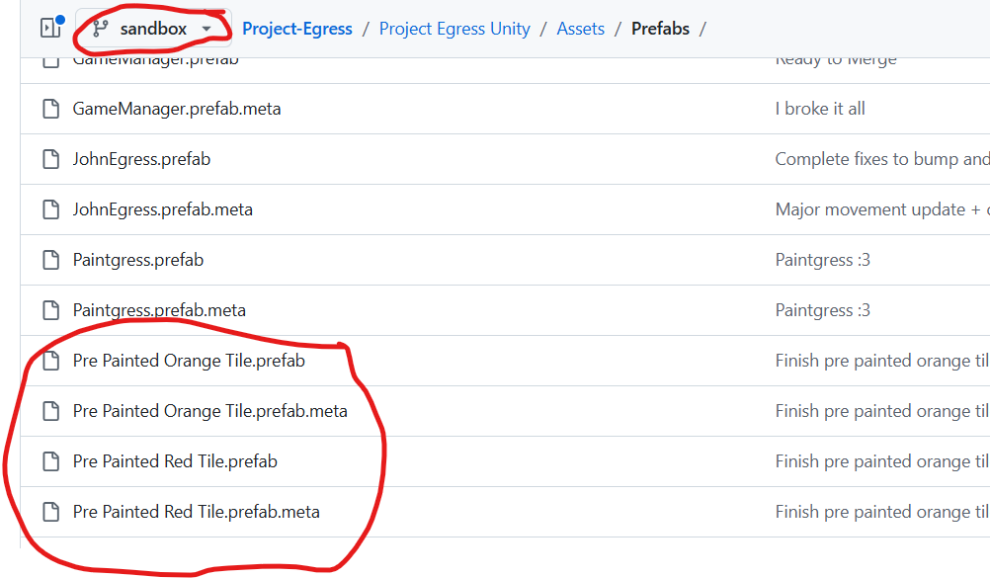

05/27/26 Archive
Block 2 to 3 (What I Did): (UPDATED: 05/27/2026 & ARCHIVED)
- General Notes:
  - We had 10 minute tech articles again today.
  - I worked more on “Level 2” and fixing some things surrounding it.
  - I started a little bit late today since I had some dumb errors (as I mentioned in the “Unity Engine Notes” below.
    - The VM was also slow too (like normal).
- Unity Engine Notes:
  - I believe I pushed and merged with the “Sandbox” branch (that was updated five days ago) properly.
    - I still got this message though when I opened the project: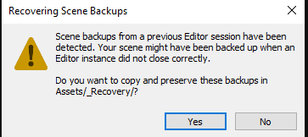
    - I hit ‘yes’ just in case.
  - Turns out I don’t think I did it properly so I tried merging again and then pushing.
    - It worked!
  - I integrated the “Pre Painted Red Tile(s)” into the spots where they would be when manually painted on.
    - It integrated surprisingly really well into what I have already done with “Level 2” so I shouldn’t be adjusting much stuff if anything (just continuing work on the level itself).
    - Of course, I just added the tiles to as few spots as needed to cross each section. The player can always add more paint to make it easier.
  - I just continued and made a lot of good progress on the level!
  - I believe all of the GitHub stuff should have worked (hopefully).
  - The first three sections are completely done (I believe) for my level and I plan on adding one (maybe two more) to complete the shell of the level.
    - I still would need to adjust spots where the player needs to (manually) paint on the proper tiles in order to beat the level.
  - I also am adjusting checkpoint locations right now (and the first two sections are good with that right now). Just figured I would mention this!
- Notes for 05/27/26:
  - I plan on continuing my progress on “Level 2” tomorrow. I want to adjust a couple of things (as I mentioned in the “Unity Hub Notes” bullet above) in the section(s) I have already made (but there shouldn’t be too much there). Other than that, I plan on adding one or two more sections to “Level 2” to fully complete the shell of the level. As I mentioned above as well, we still would need to make final adjustments (like adding the manual painting mechanic) where they are needed. I will keep you guys updated on how my progress with level creation goes in general and ask any questions where needed. Make sure to keep me updated on everything and I will too. Thank you for everything.
- Response to/ for Block 3:
  - I will get to your UI stuff later as I don't think it is entirely important at the moment. I am just trying to get the level(s) done right now so I am sticking to that for now. I also have no idea how to either so if you want to look into that for the level(s) I am making, you can, otherwise, that will be done later. Essentially, I am just following the bullet(s) I have in the section above and will only look into your UI stuff when I am done with my level (if I have time and it is self-explanatory, otherwise you can get to that, Maddie). I might get to that, but I really don't know. I could ask you questions about this later or give you a notice later, Maddie, on what I decide to do with that whenever I have the free time to theoretically work on that. Thanks for everything.

Block 3 to 2:
- I merged sandbox into your branch so that you can have my new UIs so be sure to add the pause menu to your scene and properly adjust certain aspects :3
- merged player-movement into painting
- additional changes in painting that were made were not committed due to the vm crashing

05/28/26 Archive
Block 2 to 3 (What I Did): (UPDATED: 05/28/2026 & ARCHIVED)
- General Notes:
  - I continued progress on “Level 2.”
- General Questions:
  - Maddie, what do you want me to do about your UI stuff? I just primarily continued progress on the project today because I didn’t think that was immediately important at the moment. Is it easy to integrate? If you want me to do it, then how? I do not know if I will be able to get to it either since I am kind of crunched on “Level 2” too. - Please Respond
- Unity Engine Notes:
  - I worked on and nearly completed section four of “Level 2.”
  - In terms of what I still need to do to finish section four, I just need to edit some checkpoint, teleporter, and trap decor stuff and maybe a couple of other things.
- Notes for 05/27/26:
  - I plan on continuing “Level 2” right now like I have been as well as continuing off of the notes I have if the bullet above this note with that. I will finish section four tomorrow and hopefully the final section (section five) too tomorrow. If I don't fully finish these sections and make the final edits to the shell of the level (as in the level with no background, which we will likely not get to) tomorrow then I will get back to that and finish it fully on 06/02/26. In terms of what I will do after I finish the level, I am not really sure yet. I will probably just help you guys wherever I can on the levels and stuff. I will plan that soon, but I am just going to focus on what I am doing now (obviously). And going back to that, everything I do with the rest of “Level 2” is still subject to change too so I will talk more about it when I get there. And Maddie, just note what you want to do about that UI stuff since I have no clue when I will get to that. Thank you guys for everything and keep me updated on everything and I will too!
- Response to/ for Block 3:
  - Cool, I will continue with my plan for “Level 2” as mentioned in the bullet I made above and work on what you mentioned in your bullet below when I finish (although I don't know when, I will keep you guys updated on that). Thank you for keeping me updated on everything. I will make sure to keep you guys updated too! Thank you.

Block 3 to 2:
- In order to add it properly go into menu test 2 and make sure that the button goes to level 2, make sure that the next level button on the level 1 finish flag goes to level 2 and then you should be able to just throw in the pause menu prefab (note there are no settings)
- green tile is finished and is now a prefab
  - merged into sandbox, if you want it, merge sandbox into your branch
- Maddie crashed out because the tilemaps aren’t working on her computer

05/29/26 Archive
Block 2 to 3 (What I Did): (UPDATED: 05/29/2026 & ARCHIVED)
- General Notes:
  - 10 minute tech articles like normal.
  - I continued my work on “Level 2.”
- General Questions:
  - I am doing the best I can with what I have, but there is a new bug. When you touch the “Pre Painted Red Tile,” you can no longer jump on blocks that aren’t the “Pre Painted Red Tile” (at least in my branch). Can you fix that? - Please Respond
  - Are any of you guys going to school on Senior Skip Day? - Please Respond
  - Maddie, have you started “Level 3” yet? If so, whenever I am done (which will be on Tuesday), I am going to need my branch to be merged with wherever you are working soon so my “Finish Flag” (when I add it) can be properly linked to your level. Of course, we are not there yet, but this is still important to note. - Please Respond
  - Just confirming, we are not doing any background tiles, right? I don’t think we ever clarified or followed up on this and the deadline is really close now. Are we just keeping a blank background? - Please Respond
- Unity Engine Notes:
  - I completed Section Four of “Level 2” and I am in the middle of working on Section Five (the final section) of “Level 2”!
    - I am nearly done, there are just some mechanics and things that will need to be worked through.
  - All things that need to be done with “Level 2”:
    - Buzzsaws still need to be added to Section Five.
    - “Pre Painted Red Tile” needs to be fixed so everything can be playtested one last time and edited accordingly.
    - Everything still needs to be playtested one last time and edited accordingly.
    - The Section 5 checkpoint still needs to be added.
    - The Section 5 finish flag still needs to be added.
    - UI features still need to be integrated.
    - “Level 2” needs to be merged where the “Finish Flag” can be properly linked to “Level 3.”
    - The “Level 2” “Finish Flag” still needs to be linked to “Level 3.”
    - You guys should check the level (when it is done).
  - Unless we are doing background tiles, everything I listed in the bullet above still needs to be done and should get done by the end of 06/02/26!
  - Everything should have been fetched, pulled, committed, and pushed properly in Visual Studio Code.
- Notes for 05/27/26:
  - I plan on doing as much as I can with all of the points I listed a few bullets above this bullet for “Level 2” as quickly as possible and hopefully by the end of 06/02/26 (with help from you guys on the things I mentioned earlier that need fixing and such). I don’t have answers to all my questions on this document right now so I can’t say too much about everything yet. I will get to planning and looking into what to do after “Level 2” is finished later (since there are still things that need to be done and will definitely take up the entire day on 06/02/26 at the very least). Please get back to me as soon as possible on everything. What I am doing right now and in the near future should be pretty self-explanatory given the comments I have made on this document. Just keep me updated on everything and I will do the same. Thank you! - Please Respond/ Acknowledge This
- Response to/ for Block 3:
  - Thanks for the feedback. Nothing should change from what I said in the bullet point above this and nothing should change in terms of planning based on your guy's answers so everything should be good for later as of now. Just make sure to keep me updated on everything and I will too. Thank you!

Block 3 to 2:
- Answers
  - 1. fixed
  - 2. liam: no why would i? Maddie: it’d be so funni tho think about it
  - 3. I have not started level 3 because THE STUPID SHFDKJ:JSDJKVBSDVBSDLJKFBJ TILES WON’T WORK
    - Now they are bigger for some reason
      - 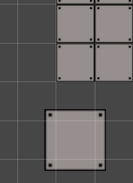
  - 4. yeah the blank background should be fine

06/02/26 Archive
Block 2 to 3 (What I Did): (UPDATED: 06/02/2026)
- General Notes:
  - I am working more on “Level 2”!
- General Questions:
  - Do you guys even have a slight plan on how everything will go? I am pretty sure we are having another check-in tomorrow. - Please Respond
  - What do you guys want me to work on? This is really important and relates to the bullet above. Where should I go? We need to get this stuff done ASAP! - Please Respond
  - Can you please review my “Unity Engine Notes” section? Feel free to make any comments where you like! It is very important I get your feedback. - Please Respond
- Unity Engine Notes:
  - I think I fetched, pulled, committed, and pushed properly.
  - I mainly just worked more on Section Five today. It is nearly complete.
  - I still need to:
    - Finish adjusting some things after playtesting.
    - Send it off to you guys (not a physical action, really).
  - I need you guys to:
    - Merge branches and stuff so we can see everything.
    - Attach the “Finish Flag” teleport to “Level 3” whenever possible.
    - Adjust the placeholder pre-painted red tiles to be empty so the player can paint.
    - Properly add the painting mechanics.
- Notes for 05/27/26:
  - I am not too sure on this. I still need you guys to get back to me.
- Response to/ for Block 3:
  - I guess I will just finish up what I can do on “Level 2” tomorrow and leave some notes for you guys accordingly on what I can't do (yet), need help with, or things you need to do. After that, I will make a new branch and continue level creation at my best accordingly (specifically “Level 4” probably). I will keep you guys updated on everything regarding that. This should cover everything for the time being up until we are done and ready for the presentation. I will make sure to notify you if anything ever changes. Make sure to keep me updated on everything too. Thank you.

Block 3 to 2:
- Not too sure on what?

06/03/26 Archive
Block 2 to 3 (What I Did): (UPDATED: 06/02/2026)
- General Notes: - Please Review
  - I am working more on “Level 2.”
  - Just to note, he gave us the outline for the “Final Report” for our Senior Capstone Project. There is a lot of information we need to have and it looks like a lot of work. Then again, it could end up not being as bad as we think. Regardless, it just means we need to get this whole project in a roughly finished state by Monday (06/08/26). I will get to planning this out on Friday, our main priority right now is just finishing the game. We will get to this later.
  - I got started on “Level 4” (but I barely got anywhere though because of an error).
  - We have to just keep going and see where we can get. I am trying my best and I am super stressed right now. The whole point of these archives, even though they can be long and comprehensive, is to keep myself and you guys in the loop on everything going on since we are split into multiple blocks. I am sorry if this is an issue. I am doing what I can when I can with the time I have so just keep going. We can do this. I will keep you guys updated on what I can or can’t do as we progress through these last few days. I am really trying, I just don’t think I am very good at this. I am sorry.
- Unity Engine Notes: - Please Review
  - I finished the last things I really can for “Level 2.” It is a relatively longer level, especially in terms of difficulty. You guys can definitely try it out if you want to. I tried my best. If you guys need me to make edits PLEASE TELL ME and I can get back to this tomorrow. Otherwise, ALL that NEEDS TO BE DONE (SO PLEASE LOOK AT THIS) is the following (I think this covers everything):
    - “Level 1” needs to be connected to “Level 2” and “Level 2” needs to be connected to “Level 3” in terms of just the “Finish Flag” prefab.
    - The placeholder paint tiles need to be removed in some places in place of where the player will actually paint.
    - Maddie, your menu still needs to be added, although I noticed it automatically was connected to the “Finish Flag” so that is good at least. I think you will need to do this since I have absolutely no idea how this actually works.
  - I published a new “Level 4” branch off of “Sandbox/Origin.”
  - Error again prevented more progress on “Level 4”:
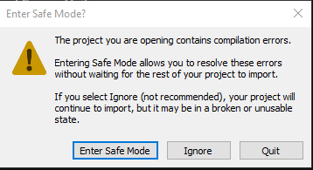
    - It seems to be an error with “Game Manager” and I don’t know why.
    - I did not flounder, but instead I managed to fix the issue by editing the “Game Manager” code. The issue was an extra “void start” and an unnecessary “using System.Numerics.” All errors were removed once those were gone. I commented the errors out so you can see I guess.
  - I got to the first steps of making “Level 4.”
    - The only progress I really got was looking into the green paint itself and I really like it!
- Notes for 06/04/26 (copy and pasted from “06/02/26 Archive” and tweaked for current progress):
  - I am doing my best with working through “Level 4” and I will keep you guys updated on everything regarding that. This should cover everything for the time being up until we are done and ready for the presentation. I will make sure to notify you if anything ever changes. Make sure to keep me updated on everything too. Thank you.
- Response to/ for Block 3:
  - One note before you guys get back to me. I plan on taking tomorrow and Friday and trying to speedrun “Level 4” as fast as possible although I don’t know if I will be able to finish. I will keep you guys updated on everything. Additionally, nothing has changed from the note above this so everything should be good for now, we just need to keep working. Other than that, just keep me notified if you guys need anything from me immediately. I will keep you guys updated too. Thank you.

Block 3 to 2:
- The back to menu should work as you have the updated finish flag which was the last thing I worked on
  - Only thing you needed to do was add the PauseCanvas prefab as it has the event controller for both UI elements
    - And also drag the pausecanvas to the pausefunction area in the finish flag
    - Fixed it on my branch so don’t touch it just keep that in mind for level 4
      - Actually moved the event system to finish flag due to errors caused by it being in pause. Again do not do anything with finish flag or pause on your branch and wait for the fixes to be pushed to yours.
      - Due to the amount of changes I would like to merge it with level4 and level2 but up to you since it is your branches
        - There is something blocking the merge between 4 and 3 so just create a pull request and liam or I will solve it
- started fixing a bug where the painted tiles will not apply their effects to the player when their colliders are combined
- IGNORE: (-4.5, 1.3)
- Started setting up a community level template, see “CL---M” (Community Level — Maddie) branch -Liam
  - To maddie: i was not able to get someone to make a level due to no template

06/04/26 Archive
Block 2 to 3 (What I Did): (UPDATED: 06/04/2026 & ARCHIVED)
- General Notes:
  - I worked more on “Level 4” today.
  - I had to switch to “Level 3” after a bug occurred.
  - Bugs generally really slowed our progress today.
  - Maddie will likely work with me in Block 2 for the rest of the Block 2s going forward (if it is allowed).
- Unity Engine Notes: - Please Review
  - I made a tiny bit of progress in “Level 4” but the mechanics of the paint are still up for debate because Maddie thought the paint worked a different way. I also agreed that it was kind of weird that you didn’t flip back to normal after leaving the tile.
  - I switched to the “Level 3” branch due to a bug.
    - There is a random jump buffer bug/ issue where you can not jump randomly.
    - Mostly solved but still happens less frequently
  - I made little progress on “Level 3” because of other bugs in Maddie’s branch. Maddie can tell you about that.
- Notes for 06/05/26 (copy and pasted from “06/03/26 Archive” and tweaked for current progress):
  - I am doing my best with working through “Level 4” (regardless of issues) and I will keep you guys updated on everything regarding that. This should cover everything for the time being up until we are done and ready for the presentation. I will make sure to notify you if anything ever changes. Make sure to keep me updated on everything too. Thank you.
- Response to/ for Block 3:
  - Just as a reminder, I plan on bringing my computer and a charger home tomorrow so I can work on more level creation stuff (because we will likely need to). I will get to that on Sunday and on a call (likely, if you guys want to). Anyway, I will continue doing what I am doing! Keep me updated on everything and I will keep you guys updated too. Thanks!

Block 3 to 2:
- LIAM PLEASE WORK ON THIS:
  - Green tile flip you back to normal after leaving
    - I thought that that is how it worked :c
  - Ethan’s branch can not jump consistently maybe a jump buffer problem
    - I fixed it mostly but it still happens from time to time
    - ALSO none of the branches are merged with the updates you made last night and they have compatibility errors

- i did not merge anything from last night, only just merged level 3 into level 4
- did not notice any inconsistent jumps
- i thought green tile keeps you in that rotation until you hit another to rotate you
  - i can change it to flip the player back to normal after leaving though
- paint gun rotates around player
- paint gun flips based on rotation

06/05/26 Archive
Block 2 to 3 (What I Did): (UPDATED: 06/04/2026)
- General Notes:
  - Short tech articles today
  - I worked more on “Level 4.”
- Unity Engine Notes: - Please Respond
  - I made a lot more progress on “Level 4” itself. This was primarily because I couldn’t really playtest due to two bugs:
    - The jumping issue is still very common for me. I don’t get it.
    - Green tiles still don’t work.
      - I have already fetched, pulled, etc. Nothing was updated.
      - I figured I would make the level based on the idea that you have to stay on the green tiles for gravity to remain flipped. This was like what Maddie said, although I don’t know if she told you, Liam. Also, like normal, I have made the level based on the assumption that the pre-painted tiles will be removed (only some of them) to allow the player to solve puzzles themselves.
  - The main things that need to be done are just bug fixes and integrating things on Sunday when we finish the project (since our last bit of progress, I believe, is just levels to the best of our ability). What I mean by this is just connecting levels, adding the pause menu everywhere, etc.
  - If you guys want to make a “Level 5” we will have to do it together. Otherwise, I can’t really figure out how to combine the paint in previous levels without making it too similar to the concept of what “Level 5” would be. Essentially, what I am saying is that without “Level 5,” the paints don’t really join into one cohesive level. Still, we don’t really have a lot of time for this.
  - Maddie, one important note, you can use the tile palette to draw the “Fire Spitter” prefab by simply changing the ‘y’ offset by ‘0.75’.
    - Generally, having access to essentially paint everything made level creation a lot faster.
    - The only thing I cannot figure out is how to rotate the “Fire Spitter” by 90 degrees when painting. Changing the orientation only works for 180 degrees. The 90 degree fix looks too complicated and confusing and would involve changing everything/ a lot of things.
  - The only things I think I need to do for “Level 4” in terms of actual level stuff (no integration) is just finishing a couple more sections maybe (including some traps and stuff), adding checkpoints where needed, adding teleporters where needed, and adding the “Finish Flag” prefab where needed. I shouldn’t have too much more to do over the weekend.
- Notes for 06/07/26 (Sunday):
  - Everything I listed above is pretty self explanatory. We have to work over the weekend and just finish up as much as we can. I will finish what I can over the weekend based on the bullets I have made above. Just let me know how everything goes your block for you guys so I can update anything where needed. Keep me updated on everything and I will too. Thank you!
- Response to/ for Block 3:
  - One quick note first. I will make sure I keep this document updated over the weekend so we can keep track of everything (possibly). I guess I will talk to you guys Sunday and we can see how things go then and how things are going by then since something sure is happening. All of my bullets above are good and I plan on sticking to them. I have nothing else to add really. Just keep me updated on everything and I will keep you guys updated too. Thank you!

Block 3 to 2:
- try merging sandbox again, my merge from yesterday might not have pushed from my end
- 500 NEW BUGS IT IS ALL OVER NOOOO PROJECT IS KILLED WE ARE KILLING THE PROJECT TEAR DOWN MY PROJECT TEAR DOWN MY HOUSE TEAR DOWN MY WIFE TEAR DOWN MY KIDS
- MIKE REBUILD THE PROJECT IN UNREAL ENGINE 6
- me when i have to juggle a billion things at once
  - working overtime at home i guess

06/07/26 Archive
Block 2 to 3 (What I Did): (UPDATED: 06/07/2026 & ARCHIVED)
- General Notes:
  - [On Call, Self-Explanatory]
- Unity Engine Notes:
  - [On Call, Self-Explanatory]
- Notes for 06/08/26:
  - I will, at the very least, do my best and start the “Final Report” assignment in any way I can. I will make sure to keep you guys updated on what I do. If I have any questions and notes, I will list them on this document. When you guys get to working on it, just keep me updated on what you guys do too. Just keep me updated on everything I will do the same too. Thank you guys for everything.
- Response to/ for Block 3:
  - First off, just as a note, I will (with Liam), ask people during lunch/ activity about a “Community Level” with other people’s input. We can work out the details over time and figure out, as we are doing this, the best time to get anyone we know (or need to work on this) to work on this. This could be done/ worked on over the course of the next few days. Also, in terms of what I plan on doing tomorrow, I will likely playtest/ clean-up “Level 4,” remove the painted blocks where I want to play to paint in “Level 2” and “Level 4,” and then start the report when I can. I will also connect the levels if we still need to and if I can (with the “Finish Flag” and stuff) before I start the report. We can work on the report at home and at any time really so it does make sense to start it after we essentially finish the entire project itself. That is essentially all for today. Cool. I will keep you guys updated just make sure to keep me updated too! Thank you.

Block 3 to 2:
- N/A [On Call/ In Discord, Self-Explanatory]

06/08/26 Archive
Block 2 to 3 (What I Did): (UPDATED: 06/07/2026)
- General Notes: - Please Review
  - I couldn’t really do anything in Unity Engine today because none of the fixes/ changes occurred from what I can tell. If something needs to be communicated about this, please tell me because I don’t know where anything is.
    - I will bring my computer home to work on this later just in case (and because why not).
  - I made the best out of my time and started the whole “Final Report” assignment.
- Unity Engine Notes: N/A
- “Final Report” Assignment Notes: - Please Review
  - I mainly started working on the “In-Class Presentation.” The details on what we want to do with that (especially in terms of formatting) can be worked out whenever you guys get the chance to work on it since there is no way I am finishing it by myself.
    - I made it (by copying and editing the midterm version (unless you guys don’t want to do that)).
    - I shared it with you guys accordingly. Liam is now the owner too!
    - I reformatted everything (to try my best and differentiate it from the midterm version).
    - I worked on it for a little bit. I kind of dabbled a little bit everywhere on it. I think I essentially did my part [I will have it done by tonight since I didn’t get everything I wanted to do in class.*] since I don’t think anything I needed to do relied too heavily on everything being completely perfect and done. Just check it out for yourself if you want to. You guys can edit the formatting a little bit too in terms of the amount of slides, information, images, etc. (if you want to).
  - For the video, I obviously did nothing. Liam will likely have to work out a lot of the details regarding that. I am not too sure if we all need to have voices or anything either so you guys can ask him the details on that if you want too.
  - I dabbled a tiny bit into the “Written Report” as well.
    - I just made the document itself. I didn’t get to actually working or formatting yet.
    - I shared it with you guys accordingly and made Liam the owner too.
- Notes for 06/09/26:
  - In-class, I plan on continuing work primarily focused on the “Written Report.” I made touch up the “In-Class Presentation” a little bit as well if I get the time to or if I want to. Other than that, there is nothing else I plan on doing tomorrow. Just keep me updated on everything and I will for you guys too. Thank you a lot for your hard work, lol, especially Liam.
- Response to/ for Block 3:
  - I will make sure that when I work on the project itself I will check to see if I need to merge (and merge accordingly), I will add the collider thingy and set everything to static in the tilemap, and I will set it to ground layer as well (on top of following the things you guys listed in your bullet(s) below). First of all, though, I plan on working a tiny bit more on the “In-Class Presentation” and getting my part done. I also took my school computer home accordingly to work on the project itself. Other than that, everything else should be good for now. This was just the stuff I plan on doing after school today. The bullet I have above indicates what I plan on doing tomorrow. Other than that, just make sure to keep me updated and I will do the same too. Thank you!
- After School Final Notes:
  - Tomorrow, I will quickly work on whatever I didn’t get to do today and then move onto the “Final Report” assignment, specifically the “Written Report” probably. What I specifically mean is that I will work on playtesting/ cleaning-up “Level 4,” removing the painted blocks where I want to play to paint in “Level 2” and “Level 4,” and then connecting the levels if we still need to and if I can (with the “Finish Flag” and stuff) before I start working on the “Written Report” (by first merging my branch with Sandbox too). I will likely spend some time after school (possibly on call with you guys if you want to) working on more of the “Written Report” stuff, “Final Report” stuff in general (possibly), and the stuff I didn’t get to today (if I don’t get to it in class tomorrow). That should essentially be everything in terms of after school updates. Just keep me updated on everything and I will too. Also Maddie, I will make sure I do more “Community Level” stuff during Lunch/ Activity Period tomorrow with Aidan too. I will make sure I fix everything based on your notes in the bullet point(s) below before allowing Aidan to work on the “Community Level” as well as remind Aidan that he can use other prefabs (in the same way he can drag the “Fire Spitter” prefab). That should be all. Thank you guys for everything!

Block 3 to 2:
- WHEN GOING TO COMMUNITY LEVEL BRANCH CHANGE FIRE SPITTER’S SIZE TO 3.125875
- IN YOUR CL BRANCH MAKE SURE YOU SET BOTH SAWS TO Is Trigger IN THE PREFAB BY CLICKING ON IT AND CLICKING THE CHECKMARK (scroll down to Polygon Collider 2D)
- DELETE THE TILE FROM THE TILE MAP AND DRAG THE PREFAB IN (where the dropdown menu is that says MyPrefabs click the pencil icon to the right of it and then use the delete brush on it then drag the tile prefab in)
- MAKE SURE WHEN PEOPLE ARE MAKING THE LEVEL THAT EVERYTHING GOES IN THE Tilemap SECTION (if it isn’t just click on the Tilemap on the left sidebar and it will work)
- We mostly worked in coding today we may or may not do the same tmr we will see (we will work on the final stuff dw)
- Paintball now clones but makes errors

06/09/26 Archive
Block 2 to 3 (What I Did): (UPDATED: 06/09/2026)
- General Notes:
  - I finished all of my part of level creation today.
- Unity Engine Notes: - Please Review
  - “Level 2” Notes:
    - I have removed spots with pre-painted tiles to allow the player to paint themselves.
    - This level just needs to be connected to the other levels in our final product (in terms of the “Finish Flag” prefab).
    - “Level 2” should be completely done otherwise (so please check it out for yourselves, especially when the paint mechanic functions)!
  - “Level 4” Notes:
    - “Level 4” has been playtested and it should be completely good!
    - I have removed spots with pre-painted tiles to allow the player to paint themselves.
    - This level still needs to be connected to the other levels in our final product (in terms of the “Finish Flag” prefab).
    - “Level 4” should be completely done otherwise (so please check it out for yourselves, especially when the paint mechanic functions)!
  - Bug Notes:
    - Green tiles have an issue (that shouldn’t affect the gameplay at all when fixed) that makes you get softlocked on the corner of a tile clipping back and forth between angles based on the gravity. You might want to look into this, Liam.
- “Final Report” Assignment Notes: - Please Review
  - I will get to work on the “Written Report” tonight and try to do as much as I can. Obviously, we will get it finished tomorrow since we have to.
  - The “In-Class Presentation” I have worked on a lot already so you guys should get to work on your parts too as I have done a lot already.
  - The same thing applies to the video as I mentioned yesterday in yesterday’s notes. Also, we can discuss the details of it more tomorrow (possibly on call after school, if needed).
- Notes for 06/10/26:
  - I should have noted everything important above so there isn’t too much left to say. Tomorrow, in-class, I plan on working on the “Written Report” primarily. This could obviously change given how plans change constantly and how you guys still need to do stuff during Block 3 today and answer my questions. Other than that, I think I mentioned everything else above so we are good. Just keep me updated on everything and I will too. Thank you!
- Response to/ for Block 3:
  - I will make sure I spend a lot of time on it. I just don't want to do the whole thing by myself. As long as we all contribute, it should be good. I don't think it should take too long anyway so we should be fine. I will spend some time working on it tonight. Other than that, everything has been listed out above already so I think we are good for now. I will make one final note later regarding everything, but otherwise, that should be everything for now. Just keep me updated on everything and I will do the same. Thank you.
- One Last Note(s) from 06/09/26:
  - I made a lot of good progress today that should be noted in this document, visibly seen in Unity Engine, and also detailed in the “Written Report” we need for our “Final Report” assignment due later. Tomorrow, in class, I plan on working on as much of the “Written Report” that I can to finish off what I planned on doing for the whole “Written Report.” I planned on mainly just doing my part for the contributions section in the “Detailed Summary” portion of the “Written Report.” I am not saying that I can’t help anywhere else, just that this is mainly where I wanted to get to. Additionally, I could write some of the “Reflection and Closing Thoughts” section and “Executive Summary” section(s) (especially if I get the time to and finish what I wanted to do tomorrow in terms of the “Written Report” done early. After school tomorrow, I plan on finishing up anything I need to on the “Written Report,” cleaning up parts of the overall “Final Report” where/ if needed, helping out with the video(s) where or if needed, and reviewing the “In-Class Presentation” to make sure I am ready for 06/11/26. Since the presentation shouldn’t be too formal, like I remember him saying, I don’t plan on going crazy with reviewing the “In-Class Presentation” and making note(s)/ note card(s) and such. Overall, this is my detailed plan for tomorrow for what I plan on doing and I plan on following it in any way I can and to the best of my ability. Anyway, make sure to keep me updated on everything and I will make sure I do the same too! Also, just as a reminder, tomorrow should be our last day recording/ using the note(s) on this document and this document in general, so cool! Thank you guys for everything and all of your hard work and effort! I really appreciate it!

Block 3 to 2:
- That sounds good. If it isn’t too much to ask since Liam and I have a lot to get done (Getting painting finished and getting the CL linked together and such respectively) is it ok if we ask you to work a little bit more than us on the final report.
  - We all will contribute dw but like just take up a larger portion of it since you finished Level 4.
  - Also finishing the slideshow today unless you think of anything else to add -Maddie
    - I can replace the images if you want I just wanted to add something a little funny
  - Slideshow is mostly finished except some stuff we can’t do until we are finished with the Demo & some pictures
- Can confirm Larp Larp Larp Sahur is indeed a melee tower

Project egress 2.0 (I accidentally hit google’s stupid “enhance” slide feature:

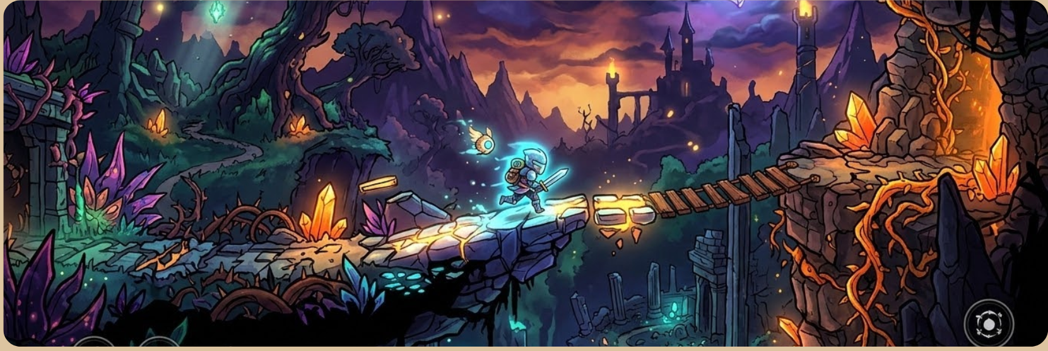

Old Resources/Info

- Get Unity Project Instructions:
  - Clone the branch (git clone -b attakdoge-add-unity-project https://github.com/Fennec427/Project-Egress.git)
  - Open Unity Hub -> Projects
  - Add -> Add project from disk
  - Go to the cloned branch folder and open the project folder titled “Project Egress Unity"
  - It should be added now? This is why we’re testing
  - If it is added, try to open the project

- Unity Details: Using home email on Unity Hub should be fine
  - Install editor version 6.3 lts from installs tab
    - web build support, windows build support (IL2CPP)

- Vscode: install unity and c# extensions

- Boost vm speeds:
  - install vmware tools (VM -> Install VMware Tools…)
    - if it doesn’t run immediately, press the notification (“What should Windows do with this disk” or smth) and press the button that has a “VM” icon
  - if vm is still slow, allocate more resources
    - increase RAM amount (add another 1024 or smth)
    - increase processor numbers (be wary of warnings, don’t go too high on total processor cores)

Resources:

Coding:
- 2d Unity: https://learn.unity.com/tutorial/2d-game-kit-walkthrough (E,L,M)
- 2d sprite rigging: https://learn.unity.com/tutorial/rigging-a-sprite-with-the-2d-animation-package (L,M,E)
- 2d asset importing: https://learn.unity.com/tutorial/importing-2d-assets-into-unity-2019-3 (M,L,E)
- Unity: https://www.youtube.com/watch?v=XtQMytORBmM - Don’t bother yet I guess.
- C# intro: https://www.codecademy.com/learn/learn-c-sharp-introduction (L,E,M)

Art:
- Pixel art maker: https://www.piskelapp.com/ (E,L,M)
- Animated Sprites: https://www.youtube.com/watch?v=7AKGb2sg19E (E,,)
Virtual Machine Instructions:
- iso file for vmware (ur welcome)
  - ^ better than what holden children is using
  - Instructions for install:
    - Open vmware -> Create a new virtual machine
    - Select Custom (advanced), press next
    - Select Install the operating system later, press next
    - Guest Operating System -> Microsoft Windows
    - Version -> Windows 10 x64
    - Name it whatever or smth
    - Leave firmware as is
    - 2 processors, 2 cores per processor
    - Memory 4GB (4096MB)
    - Leave network connection as is
    - leave i/o controller as is
    - leave disk type as is
    - leave disk as is
    - leave max disk size, select store virtual disk as a single file
    - name the disk anything, as long as it ends in “.vmdk”
    - press finish
    - under devices, press
    - “Use ISO image file:” -> browse and select the iso file downloaded
    - press ok
    - press Power on this virtual machine (if you need to move back to here, press CTRL ALT)
    - close any popups if there are any
    - follow the prompt when starting (aka press a key when it tells you to)
      - if it says “Time out” then restart by pressing restart guest
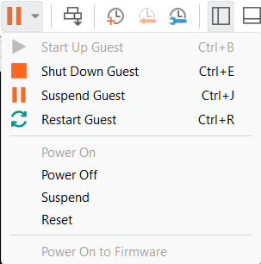
    - Next
    - Install Now
    - Wait until “Setup is starting” is replaced by a new window
    - Press “I don’t have a product key” to the left of the next button
    - Press “Windows 10 IoT Enterprise LTSC”, then hit next
    - Right click on this icon in the bottom right corner and hit “Disconnect”
    - a c c e p t t h e l i c e n s i n g t e r m s
    - Press “Custom: Install Windows only (advanced)”
    - Press next
    - Let it do its thing
    - Press yes
    - Press yes, then press skip
    - Press “I don’t have internet” in the bottom left, if you don’t see the “Let’s connect you to a network” screen:
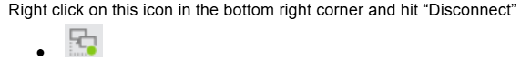
    - Press Continue with limited setup
    - Set a name, any name you want, it can be anything
    - Set a password
    - Security Questions: be serious (or not)
    - Turn off all the sliders on privacy settings (tracking and slop that slows down the pc), and press accept
    - Let it do its thing
    - Remember that icon from earlier? Right click it and press Connect
    - Press no on that giant blue box on the right
    - Open Powershell as admin on the vm
    - Run command: “irm https://get.activated.win | iex”
    - When a menu is shown, press 1
    - Let it do its thing
    - Press any key when it tells you to
    - When the menu pops back up, press zero
    - Check Windows Update and restart if you have to
    - Other than that, you’re done!

